**Comparative Analysis of Traditional and Deep Learning-Based Feature Extraction Methods for Plant Village Dataset**

**ASSIGNMENT REPORT**

***Submitted to***

**Amrita Vishwa Vidyapeetham**

***in partial fulfilment for the award of the degree of***

**BACHELOR OF TECHNOLOGY IN COMPUTER SCIENCE AND ENGINEERING**

***By***

**G SRIMAAN**

**CH.SC.U4AIE23015**

**N. BHARGAV**

**CH.SC.U4AIE23037**

**M. RAJ DHANUSH**

**CH.SC.U4AIE23064**

## **Supervisor**

**Dr. Deepak K**

**AMRITA VISHWA VIDYAPEETHAM**

**AMRITA SCHOOL OF COMPUTING**

**CHENNAI – 601103**

**October 2024**



**BONAFIDE CERTIFICATE**

Certified that this project report **“Comparative Analysis of Traditional and Deep Learning-Based Feature Extraction Methods for Plant Village Dataset”** is the bonafide work of **“G. SRIMAAN, N. BHARGAV, M. RAJ DHANUSH”** who carried out the project work under my supervision.

**SIGNATURE**

**Dr. Deepak K**

**SUPERVISOR**

Associate Professor, Dept. of CSE.

Amrita School of Computing

Chennai.

**INTERNAL EXAMINER**



**DECLARATION BY THE CANDIDATE**

I declare that the report entitled **“ Comparative Analysis of Traditional and Deep Learning-Based Feature Extraction Methods for Plant Village Dataset ”** submitted by me for the degree of Bachelor of Engineering is the record of the assignment work carried out by me under the guidance of **“ Dr. DEEPAK K”** and this work has not formed the basis for the award of any degree, diploma, associateship, fellowship, titled in this or any other University or other similar institution of higher learning.

**GAJJELLI SRIMAAN**

**(CH.SC.U4AIE23015)**

**NAMMI BHARGAV KRISHNA BHANU TEJA**

**(CH.SC.U4AIE23037)**

**MANUKONDA RAJ DHANUSH**

**(CH.SC.U4AIE23064)**

**ABSTRACT**

The paper is a well-rounded analysis of the efficacy of various image feature extraction methods and how they affect the classification of multitude of machine learning paradigms. Several traditional and deep learning-based techniques were investigated and include Histogram of Oriented Gradients (HOG), Local Binary Patterns (LBP), Edge Detection, Scale-Invariant Feature Transform (SIFT), Gray Level Co-occurrence Matrix (GLCM), Oriented FAST and Rotated BRIEF (ORB), and deep feature extraction using ResNet. After the preliminary comparative evaluation, four methods including HOG, LBP, Edge Detection, and ResNet have been revealed as the most promising methods to be detailed experimented. To test the suggested pipeline, a custom coin dataset was created that included systematic preprocessing (grayscale conversion, resizing, and normalization), feature extraction, and classification with several machine learning algorithms including Logistic Regression, K-Nearest Neighbors (KNN), Decision Trees, and Random Forests. To obtain strong assessment, model performance was evaluated using the standard and sophisticated measures, i.e., accuracy, F1-score, ROC-AUC, Cohen kappa, confusion matrix analysis, and stress-testing with noise and augmentation. These findings reflected the complementary capabilities of the handcrafted descriptors and deep learning-based systems and trade-offs between their accuracy, computation complexity, and stability. Overall, the results can be regarded as an important piece of evidence on the relative efficacies of traditional and deep feature extraction methods that have practical implications when applied to the classification task in practice in the case of coin recognition.

**Keywords:** Image Preprocessing, Image Feature Extraction, Histogram of Oriented Gradients (HOG), Local Binary Patterns (LBP), Edge Detection, ResNet, VGGNet, Classification, Random Forests, ROC-AUC, Confusion Matrix

**ACKNOWLEDGEMENT**

This project work would not have been possible without the contribution of many people. It gives me immense pleasure to express my profound gratitude to our honorable Chancellor **Sri Mata Amritanandamayi Devi,** for her blessings and for being a source of inspiration. I am indebted to extend my gratitude to our Director, **Mr. I B Manikantan** Amrita School of Computing and Engineering, for facilitating us all the facilities and extended support to gain valuable education and learning experience.

I register my special thanks to **Dr. V. Jayakumar,** Principal,Amrita School of Computing and Engineering for the support given to me in the successful conduct of this project. I wish to express my sincere gratitude to my supervisor **Dr. DEEPAK K,** Assistant Professor, Department of Computer Science,for his inspiring guidance, personal involvement and constant encouragement during the entire course of this work.

I am grateful to Project Coordinator, Review Panel Members and the entire faculty of the Department of Computer Science & Engineering, for their constructive criticisms and valuable suggestions which have been a rich source to improve the quality of this work.

**GAJJELLI SRIMAAN,**  
 **NAMMI BHARGAV KRISHNA BHANU TEJA**   
 **and MANUKONDA RAJ DHANUSH**

**(Reg. No. CH.SC.U4AIE23015, CH.SC.U4AIE23037**

**& CH.SC.U4AIE23064)**

**TABLE OF CONTENTS**

|  |  |  |
| --- | --- | --- |
| **Section No.** | **Title** | **Page No.** |
| – | Abstract |  |
| – | List of Figures |  |
| – | List of Tables |  |
| – | List of Symbols and Abbreviations |  |
| **1** | **INTRODUCTION** | 11 |
| 1.1 | Background | 11 |
| 1.2 | Feature Extraction Techniques | 11 |
| 1.3 | Classification Models | 11 |
| 1.4 | Evaluation Metrics | 12 |
| **2** | **OBJECTIVES** | 12 |
| **3** | **LITERATURE REVIEW** | 13 |
| 3.1 | Histogram of Oriented Gradients (HOG) | 13 |
| 3.2 | Local Binary Patterns (LBP) | 13 |
| 3.3 | Edge Detection | 13 |
| 3.4 | ResNet (Deep Feature Extractor) | 14 |
| 3.5 | Plant Village Dataset | 14 |
| 3.6 | Evaluation Metrics | 14 |
| **4** | **EXPERIMENTATION** | 15 |
| 4.1 | Dataset | 15 |
| 4.2 | Preprocessing Steps | 17 |
| 4.3 | Experimental Setup | 19 |
| **5** | **EXPERIMENTS AND RESULTS** | 20 |
| 5.1 | Histogram of Oriented Gradients (HOG) | 20 |
| 5.2 | Local Binary Patterns | 27 |
| 5.3 | Edge | 36 |
| 5.4 | Deep Learning Models using classifiers | 45 |
| **6** | **ANALYSIS** | 48 |
| 6.1 | Comparison of the results obtained | 49 |
| 6.2 | Computational analysis | 50 |
| **7** | **CONCLUSION** | 55 |
| 7.1 | Best Performing Methods | 55 |
| **8** | **REFERENCES** | 57 |

**LIST OF FIGURES**

|  |  |  |
| --- | --- | --- |
| **Fig. No.** | **Figure Title/ Name** | **Page No.** |
| 1 | Dataset Example | 15 |
| 2 | Evaluation Metrics of HOG+LR | 20 |
| 3 | Confusion Matrix using HOG+LR | 21 |
| 4 | Evaluation Metrics of HOG + KNN | 22 |
| 5 | Confusion Matrix for HOG+KNN | 23 |
| 6 | Evaluation Metrics of HOG +Decision Tree | 24 |
| 7 | Confusion Matrix HOG+ Decision Tree | 25 |
| 8 | Evaluation metrics of HOG+ Random forest | 26 |
| 9 | Confusion Matrix HOG + (Random Forest) | 27 |
| 10 | Evaluation metrics of LBP +Logistic- Regression | 28 |
| 11 | Evaluationmetrics of LBP+KNN | 29 |
| 12 | Evaluation Metrics of LBP+KNN | 30 |
| 13 | Confusion Matrix of LBP+KNN | 31 |
| 14 | Evaluation metrics of LBP +Decision Tree | 32 |
| 15 | Confusion Matrix of LBP +Decision Tree | 33 |
| 16 | Evaluation metrics of LBP + Random Forest | 34 |
| 17 | Confusion matrix of LBP + Random Forest | 35 |
| 18 | Evaluation metrics of Edge+ Logistic Regression | 36 |
| 19 | Confusion Matrix using EDGE (LR) | 37 |
| 20 | Evaluation metrics of Edge + KNN | 38 |
| 21 | Confusion Matrix using EDGE (KNN) | 39 |
| 23 | Confusion Matrix using EDGE+ (DT) | 40 |
| 24 | Evaluation Metrics Edge + Random Forest | 41 |
| 25 | Confusion Matrix of Edge + (Random Forest) | 42 |
| 26 | Accuracy by Classifier and feature | 43 |
| 27 | F1 by Classifier & Feature | 44 |
| 28 | Kappa by Classifier and Feature | 45 |
| 29 | Accuracy of Classifier and Backbone | 46 |
| 30 | F1 Score by Classifier and Backbone | 47 |
| 31 | Kappa by classifier and Backbone | 48 |
| 32 | MobileNet+Logistic Regression | 55 |
| 33 | Confusion Matrix of VGG16+Logistic Regression | 56 |

**LIST OF TABLES**

|  |  |  |
| --- | --- | --- |
| **Table. No.** | **Table Title/Name** | **Page. No.** |
| 1 | Comparison of Feature Extraction Methods with Classifiers | 49 |
| 2 | Comparison of Deep learning Models with Classifiers | 50 |
| 3 | Trade-offs Between Traditional and Deep Learning-Based Feature Extraction | 52 |

**LIST OF SYMBOLS AND ABBREVIATIONS**

**HOG** – Histogram of Oriented Gradients

**LBP** – Local Binary Patterns

**GLCM** – Gray-Level Co-occurrence Matrix

**SIFT** – Scale-Invariant Feature Transform

**CNN** – Convolutional Neural Network

**KNN** – K-Nearest Neighbors

**DT** – Decision Tree

1. **INTRODUCTION**

**1.1 Background**

Image classification is a core task in computer vision, widely applied in fields such as object detection, medical diagnostics, currency recognition, and industrial automation. The effectiveness of classification systems depends heavily on the choice of feature extraction techniques and machine learning models. While deep learning approaches like convolutional neural networks (CNNs) have gained prominence, traditional handcrafted methods still offer valuable insights, especially in tasks with limited data or computational constraints.

**1.2 Feature Extraction Techniques**

Feature extraction is a crucial step that transforms raw images into meaningful representations for classifiers. In this study, we explored a range of techniques:

* **Histogram of Oriented Gradients (HOG):** Captures gradient orientations and is effective for shape-based recognition.
* **Local Binary Patterns (LBP):** Encodes local texture by comparing pixel neighborhoods.
* **Edge Detection:** Highlights structural boundaries and object outlines.
* **ResNet (Residual Networks):** A deep learning model that automatically learns hierarchical features.
* **Other Methods Explored:** Scale-Invariant Feature Transform (SIFT), Oriented FAST and Rotated BRIEF (ORB), and Gray-Level Co-occurrence Matrix (GLCM).

After initial analysis, HOG, LBP, Edge Detection, and ResNet were chosen as the most effective methods for further evaluation on the coin's dataset.

**1.3 Classification Models**

To evaluate extracted features, we employed both simple and ensemble machine learning models:

* **Logistic Regression** – A linear baseline model.
* **K-Nearest Neighbors (KNN)** – A distance-based non-parametric classifier.
* **Decision Trees** – Rule-based hierarchical classification.
* **Random Forests** – An ensemble of decision trees for improved generalization.

**1.4 Evaluation Metrics**

A comprehensive set of evaluation metrics was used to assess classifier performance:

* **Accuracy** – Overall correctness of predictions.
* **Precision, Recall, F1-score** – Measures for handling class imbalances.
* **ROC-AUC** – Discriminative ability of the model across thresholds.
* **Confusion Matrix Analysis** – Class-wise error distribution.
* **Cohen’s Kappa** – Agreement measure beyond chance.
* **Robustness Testing** – Model performance under noisy and augmented inputs.

1. **OBJECTIVES**

The main objectives of this study are:

1. To compare handcrafted and deep learning-based feature extraction techniques.
2. To analyse the impact of different classifiers on extracted features.
3. To evaluate models using both standard and advanced metrics.
4. To investigate robustness under noisy or augmented image inputs.

# **3. LITERATURE REVIEW**

Plant disease detection depends heavily on effective feature extraction from leaf images. Early computer-vision approaches used handcrafted descriptors (edges, textures, gradients), while modern approaches rely on deep CNN features. Feature extraction reduces raw images into discriminative numerical patterns for classification. Common handcrafted descriptors include gradient-based (Sobel, Canny), texture-based (GLCM, LBP), and key point-based (SIFT, ORB), which are typically paired with classifiers such as SVM, RF, or CNNs. The **PlantVillage dataset** (~54K leaf images, 38 classes) has become the benchmark for this domain due to its large size, reliable labels, and preprocessing suitability [1][2].

#### **3.1 Histogram of Oriented Gradients (HOG)**

HOG computes gradient histograms over local cells and concatenates them into feature vectors. It is robust to illumination and small shifts, making it effective for shape-based recognition. In plant disease studies, HOG combined with CNNs achieved perfect accuracy on the Folio dataset [4], and HOG with SVM/RF also showed good performance [5]. However, HOG produces high-dimensional features, which makes it computationally heavy and less robust to scale or rotation without preprocessing.

#### **3.2 Local Binary Patterns (LBP)**

LBP encodes local texture by thresholding pixel neighborhoods into binary codes. It is simple, fast, and efficient, producing compact histograms with strong discriminative power [6]. Extensions such as rotation-invariant and ternary patterns improve robustness to noise [7]. LBP has been applied in medical imaging and plant disease classification, e.g., Wang et al. (2019) used LBP with CNNs for pathology pre-diagnosis [8]. While effective and interpretable, LBP is sensitive to illumination changes unless enhanced by robust variants.

#### **3.3 Edge Detection (Sobel, Canny, etc.)**

Classical edge operators highlight boundaries using gradient filters. Sobel and Prewitt apply simple convolutions, while Canny performs multi-stage smoothing, suppression, and hysteresis, producing sharper and more localized edges. Studies confirm Canny’s superior accuracy [9][10], though Sobel is often preferred in resource-limited settings for its simplicity and efficiency [11]. Thus, edge detection is computationally cheap but lacks fine-grained discriminative power for disease recognition.

#### **3.4 ResNet (Deep Feature Extractor)**

ResNets use residual (skip) connections to enable very deep networks while avoiding vanishing gradients [12]. As feature extractors, pre-trained ResNets often outperform handcrafted methods. However, performance varies with dataset size. For example, Kalaiyarasi et al. (2024) found ResNet-152 achieved 91% accuracy, while ResNet-50 underperformed (68%) on a tomato dataset, whereas MobileNetV2 achieved 97% [13]. In medical imaging, ResNet-50 performed well (ChestX-ray8: 69.67%) [14]. ResNets are powerful but computationally heavier and less interpretable, making lightweight models like MobileNet more attractive for efficiency-critical tasks.

#### **3.5 PlantVillage Dataset**

PlantVillage includes ~54–55K images across 38 classes of healthy and diseased crops [1][2]. Images are high-quality, labeled, and available in color/grayscale, with hundreds per class. Its scale and diversity make it ideal for benchmarking handcrafted vs. deep features. Handcrafted descriptors can be tested thoroughly, while CNNs can leverage the large dataset to learn robust features.

#### **3.6 Evaluation Metrics**

Performance is typically measured with **accuracy, precision, recall, and F1-score**, with F1 offering a balanced measure. Specificity (true negatives) and ROC-AUC are also reported in some studies. For example, Kalaiyarasi et al. reported 97% accuracy and 95% F1 [13], while Yogeshwari et al. showed CNNs outperforming SVMs (97.1% vs. 92.6% F1) [26]. Confusion matrices are often used to identify misclassification patterns. Overall, deep learning models consistently achieve higher accuracy and robustness than traditional methods

**4. EXPERIMENTATION**

**4.1. Dataset**

This study uses the **PlantVillage dataset**, a widely adopted benchmark for plant disease recognition.

* **Total Samples:** ~54,000 leaf images
* **Number of Classes:** 38 (healthy and diseased conditions across 14 crops)
* **Crops:** Apple, Blueberry, Cherry, Corn, Grape, Orange, Peach, Bell Pepper, Potato, Raspberry, Soybean, Squash, Strawberry, Tomato
* **Diseases:** Apple Scab, Black Rot, Northern Leaf Blight, Bacterial Spot, Early/Late Blight, Powdery Mildew, Leaf Mold, viral infections, plus healthy categories.
* **Distribution:** Some crops (e.g., Tomato) include multiple disease types (9 + healthy), while others have fewer.
* **Data Conditions:** Captured in controlled lab settings with uniform backgrounds for clear visibility and minimal noise.
* **Data Format:** JPG images, publicly available via Kaggle and TensorFlow Datasets.

The dataset’s scale and balance make it robust for deep learning models (e.g., ResNet), while still challenging for handcrafted features due to fine-grained inter-class similarities (e.g., Tomato Early vs. Late Blight). Its standardized, well-labeled structure ensures reproducibility and fair comparisons across methods.

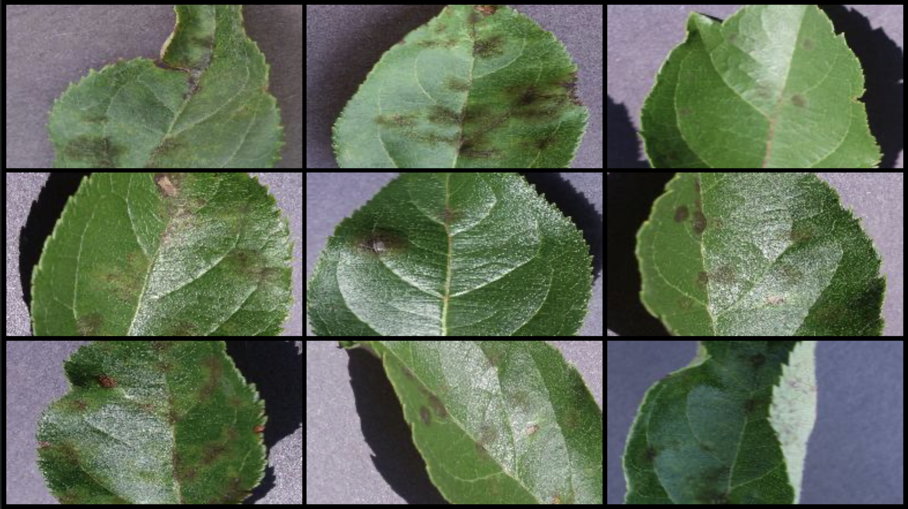  
  
**Fig.1. Dataset Example**

PlantVillage dataset was chosen because it is:

1. **Comprehensive** – covering multiple crops and disease types.
2. **Standardized** – widely used in the research community, enabling benchmarking and comparability.
3. **Relevant** – directly applicable to agricultural disease management, with strong potential for real-world deployment.

**4.2. Preprocessing Steps**   
Before feature extraction, the images from the Plant Village dataset were pre-processed to ensure consistency and enhance the quality of the extracted features. The key preprocessing steps included:

## **Traditional Models**

* Feature-specific preprocessing (via feature_generator()):
* Resized images to **128×128 pixels** and converted to grayscale.
* Applied **normalization** (pixel values scaled to [0,1]) for stability.
* Extracted handcrafted features (HOG, LBP, Edge) → fed into classifiers.

In traditional models, a **feature generator** was used for preprocessing. Each image from the PlantVillage dataset was resized to **128×128 pixels** and converted to grayscale, ensuring uniform input across all samples. To improve stability and reduce sensitivity to illumination, pixel values were **normalized to the range [0,1]**. From these normalized grayscale images, handcrafted descriptors such as HOG, LBP, and Edge features were extracted and transformed into numerical feature vectors, which were subsequently passed into classifiers including Logistic Regression, KNN, Decision Tree, and Random Forest.

## **Deep Learning Models**

* Used **Keras (ImageDataGenerator( ))** for preprocessing and augmentation.
* Resized inputs (e.g., **224×224**) and preserved RGB channels.
* Applied **normalization** ([0,1]) to align with pretrained CNN backbones.

For deep learning models, an **image generator** was employed using Keras/TensorFlow’s (ImageDataGenerator ( )). Images were resized to match the input dimensions of the CNN backbones (224×224 for ResNet50, VGG16, and MobileNetV2), while retaining RGB channels since color information plays a critical role in CNN-based feature extraction. The pixel values were **normalized to [0,1]**, ensuring stable convergence and compatibility with pretrained ImageNet weights. In addition, augmentations such as random flips, rotations, and zooming were applied to enhance robustness and reduce overfitting, thereby improving the generalization capability of the models.

**4.3. Experimental Setup**

**4.3.1. Histogram of Oriented Gradients (HOG)**

Histogram of Oriented Gradients is a classical feature extraction approach that captures local shape and edge information by computing gradients of pixel intensities in small spatial regions (cells) and constructing histograms of gradient orientations. These histograms are further normalized over larger blocks to provide robustness to illumination and small transformations. HOG is widely used for object detection and pattern recognition due to its effective representation of structural information.  
Classifiers applied to HOG features:

* **Logistic Regression (LR):** Evaluates the linear discriminative power of gradient orientation histograms to separate leaf categories.
* **K-Nearest Neighbors (KNN):** Relies on similarity in gradient orientation distributions to match samples with similar structural patterns.
* **Decision Tree (DT):** Learns rules based on orientation histogram bins, capturing non-linear combinations of local shape descriptors.
* **Random Forest (RF):** Aggregates multiple trees to enhance robustness in distinguishing leaf shapes and lesion patterns from gradient-based features.

**4.3.2. Local Binary Patterns (LBP)**

Local Binary Patterns is a texture descriptor that encodes the local spatial structure by thresholding neighbourhood pixel intensities against the centre pixel, forming binary patterns. Histograms of these patterns summarize local texture, making LBP invariant to monotonic illumination changes and effective for distinguishing fine-grained surface textures.  
  
Classifiers applied to LBP features:

* **Logistic Regression (LR):** Provides a baseline for assessing separability of local texture histograms under linear assumptions.
* **K-Nearest Neighbors (KNN):** Compares similarity in binary pattern histograms to group leaves with analogous surface textures.
* **Decision Tree (DT):** Constructs hierarchical rules from LBP codes to capture diverse and subtle texture variations.
* **Random Forest (RF):** Boosts classification stability and accuracy by averaging decisions across trees trained on different LBP-derived subsets.

**4.3.3. Edge Detection**

Edge detection methods emphasize boundaries and significant changes in pixel intensities within images, capturing essential structural information complementary to other descriptors. Common operators like Sobel, Prewitt, and Canny detect horizontal, vertical, and diagonal edges. These features are particularly helpful for identifying distinct shapes and lesion boundaries in plant leaves.

Classifiers applied to Edge features:

* **Logistic Regression (LR):** Assesses the linear separability achievable with edge-based features as a baseline.
* **K-Nearest Neighbors (KNN):** Uses similarity comparisons of edge maps to classify samples.
* **Decision Tree (DT):** Generates hierarchical rules from edge features to capture non-linear variations in leaf patterns.
* **Random Forest (RF):** Combines multiple decision trees for robust classification considering variations in leaf shapes and lesion contours.

**4.3.4. ResNet (Residual Network)**

ResNet is a deep convolutional neural network architecture featuring residual connections that facilitate training very deep models without vanishing gradient issues. Pre-trained ResNet models were employed as feature extractors to obtain high-level hierarchical image embeddings representing shape, texture, and complex visual patterns simultaneously. Deep features generally outperform handcrafted ones given sufficient data.

Classifiers applied to ResNet features:

* **Logistic Regression (LR):** Serves as a linear baseline leveraging ResNet’s high-level embeddings for quick classification.
* **K-Nearest Neighbors (KNN):** Uses similarity in deep feature space, often performing well due to the discriminative nature of ResNet embeddings.
* **Decision Tree (DT):** Attempts to split on abstract deep features, though performance may be limited due to feature complexity.
* **Random Forest (RF):** Enhances performance by combining multiple trees, effectively handling the rich, high-dimensional ResNet representations.

**5. EXPERIMENTS AND RESULTS**

**5.1. Histogram of Oriented Gradients (HOG)**

**A) Logistic Regression (LR)**  
  
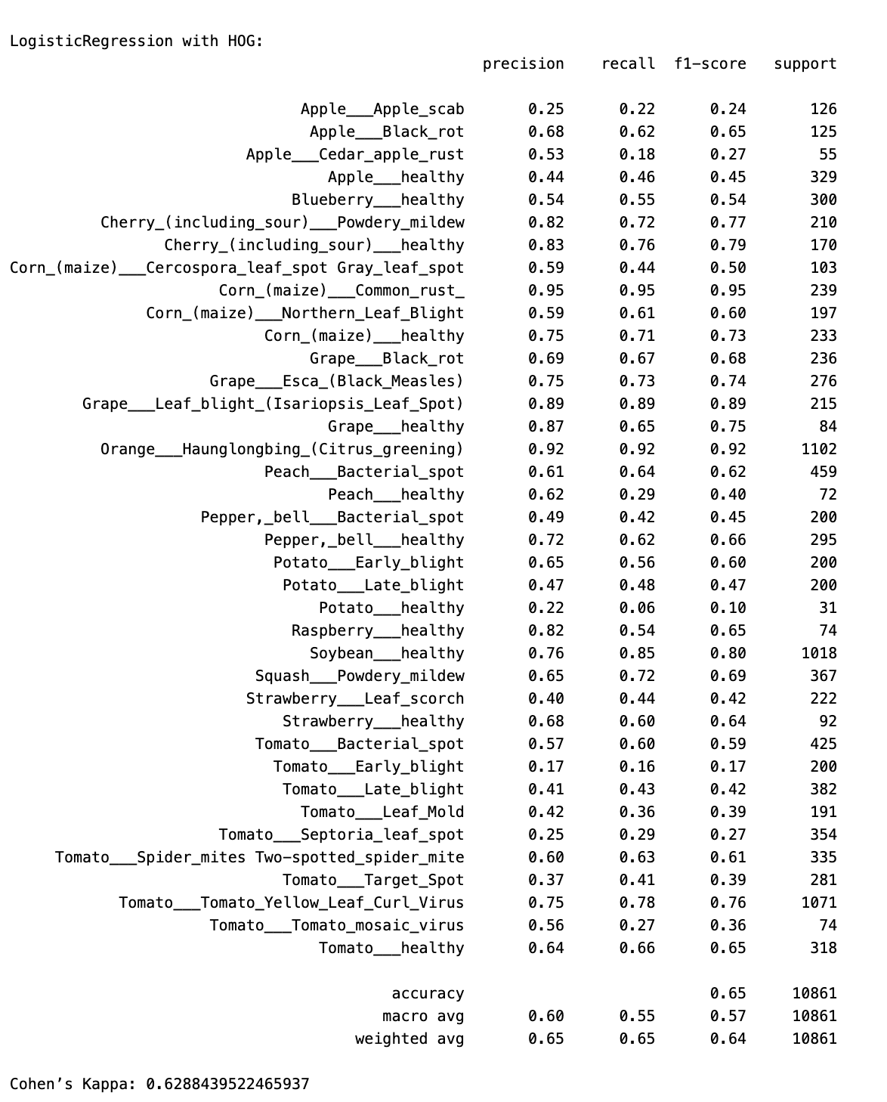

**Fig.2. Evaluation Metrics of HOG + Logistic Regression**

**Confusion Matrix:**

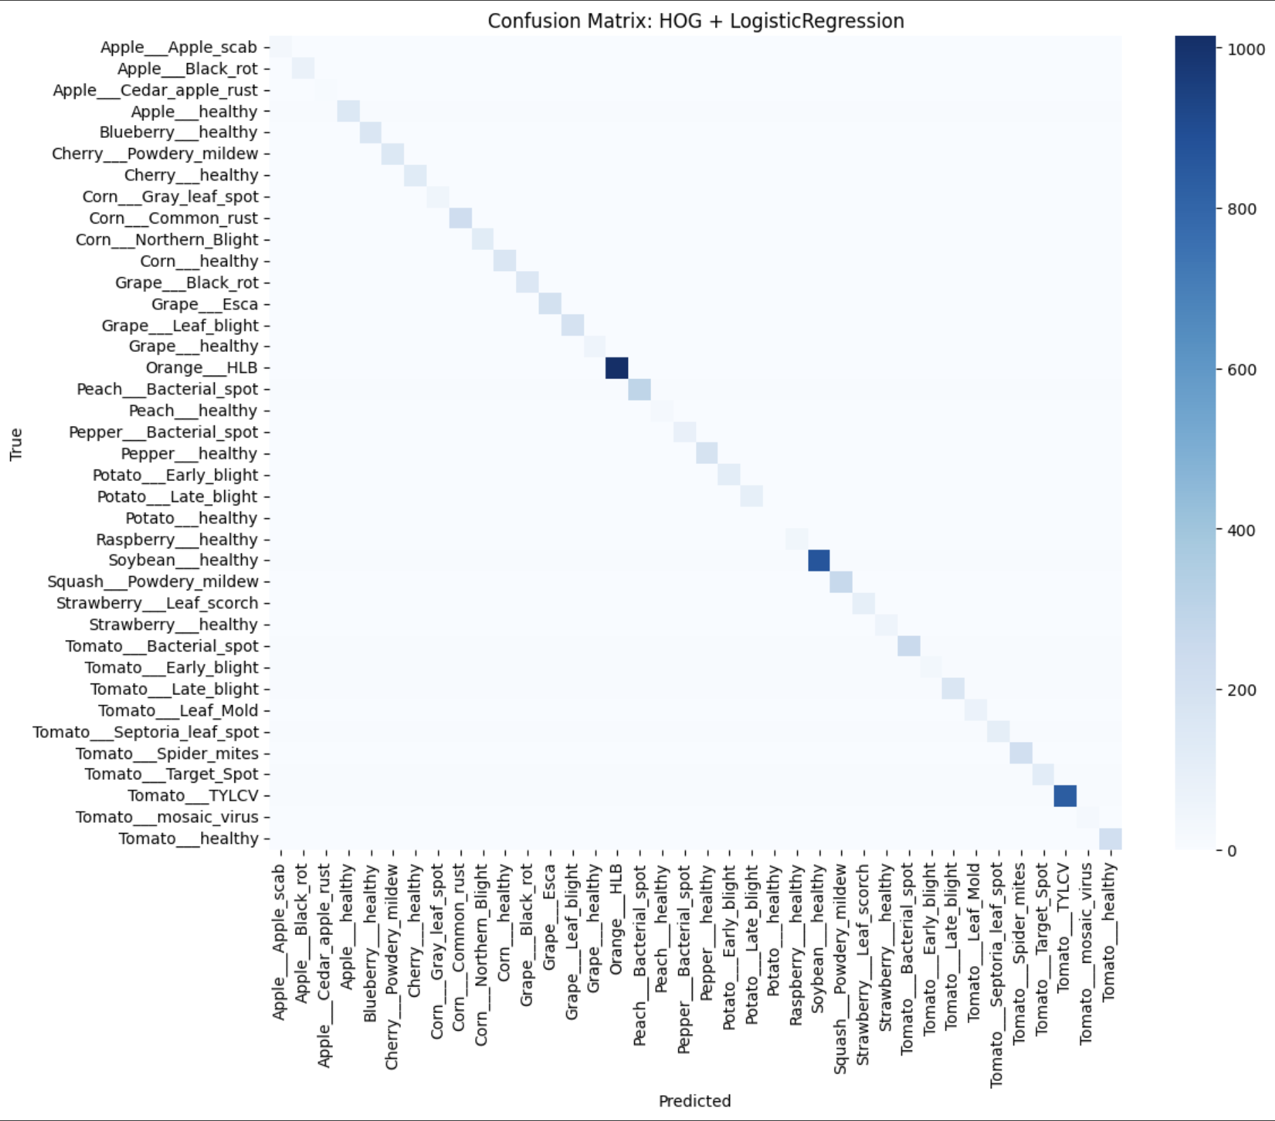  
 **Fig.3. Confusion Matrix using HOG+LR**

The model achieved **65% accuracy**, **F1 0.64**, and **Kappa 0.63**, showing **moderate performance**. It performs strongly on Citrus greening, Corn rust, Grape leaf blight, Soybean healthy, and Tomato TYLCV **(F1 > 0.75)**, but struggles with Potato healthy, Tomato Leaf Mold, Tomato Target Spot, and Tomato Mosaic Virus **(F1 < 0.4)**, especially when differences between healthy and diseased leaves are subtle.

**B) KNN**   
  
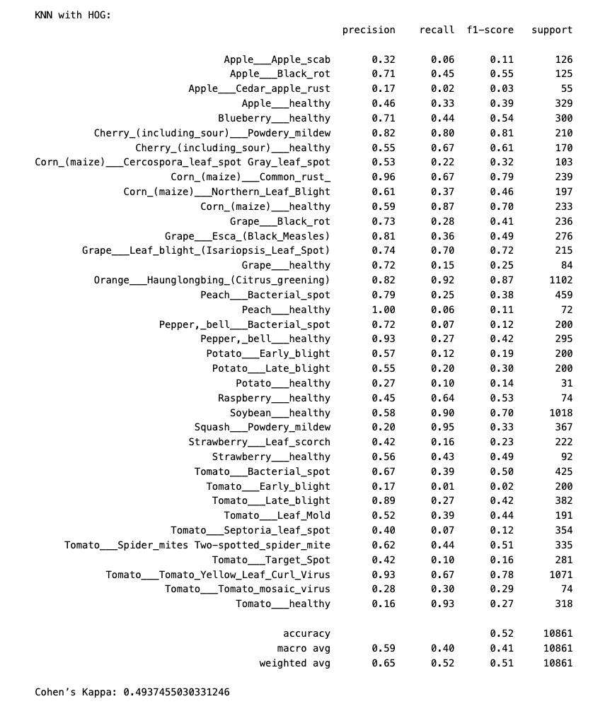

**Fig4: Evaluation Metrics of HOG + KNN**

**Confusion Matrix:**

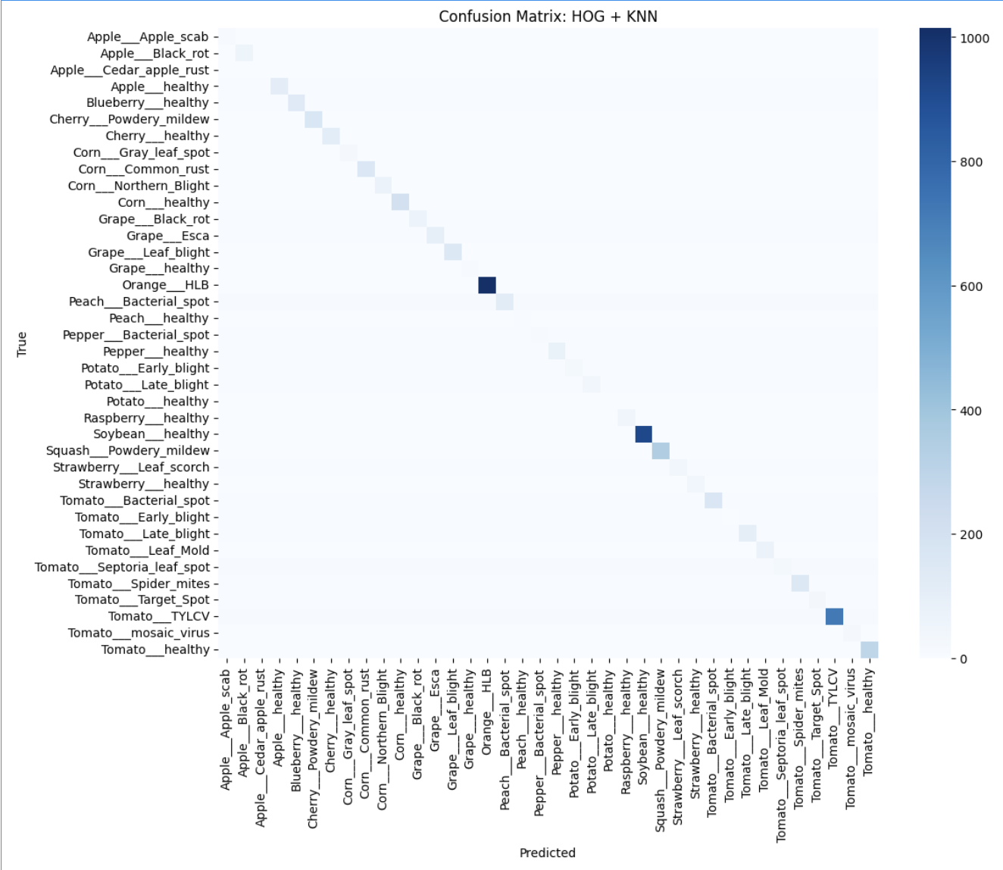  
**Fig.5.Confusion Matrix for HOG+KNN**

The model shows **weak overall performance** with **52% accuracy**, **F1 0.51**, and **Kappa 0.49**, performing below Logistic Regression. It detects **Citrus** greening, Corn rust, Cherry powdery mildew, Grape leaf blight, and Tomato TYLCV well (F1 ≥ 0.72), but many other classes have F1 < 0.3, as KNN exhibits high precision but low recall, failing to generalize for subtle or healthy cases.

**C) Decision Tree**   
  
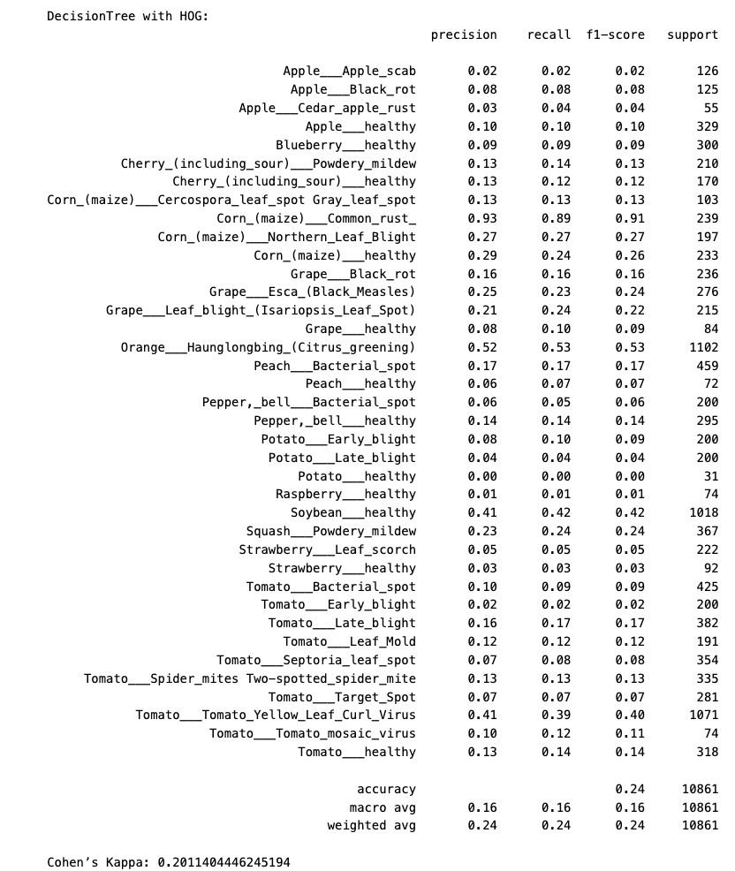

**Fig.6.Evaluation Metrics of HOG +Decision Tree**

**Confusion Matrix:**

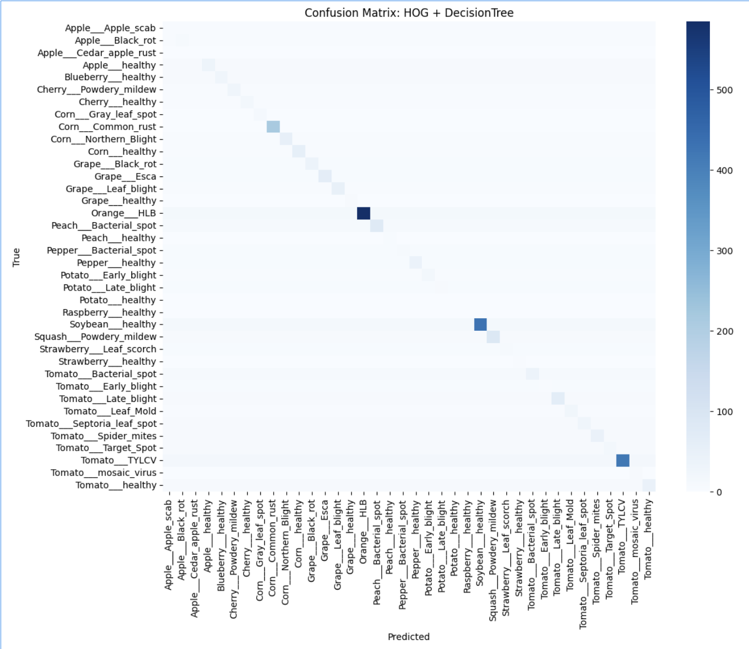

**Fig.7.Confusion Matrix HOG+ Decision Tree**

The model shows **very poor overall performance** with **24% accuracy**, **F1 0.24**, and **Kappa 0.20**. It performs well only for Corn rust (F1 0.91), Citrus greening (F1 0.53), and Soybean healthy (F1 0.42), but severely overfits, failing on most other classes (F1

≤ 0.10).

**D) Random Forest**

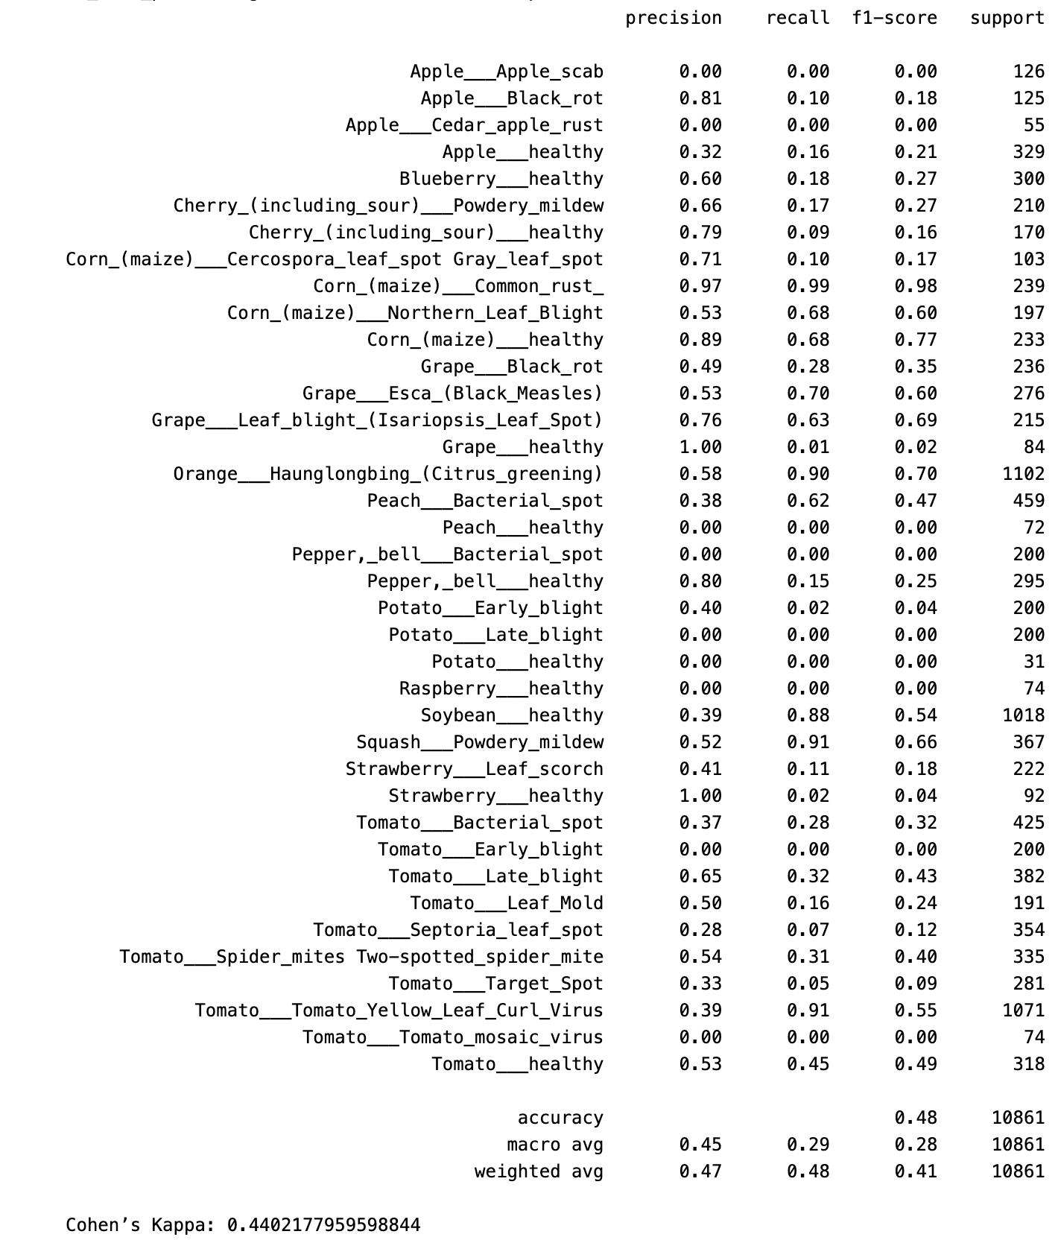 **Fig.8.Evaluation metrics of HOG+ Random Forest**

**Confusion Matrix:**

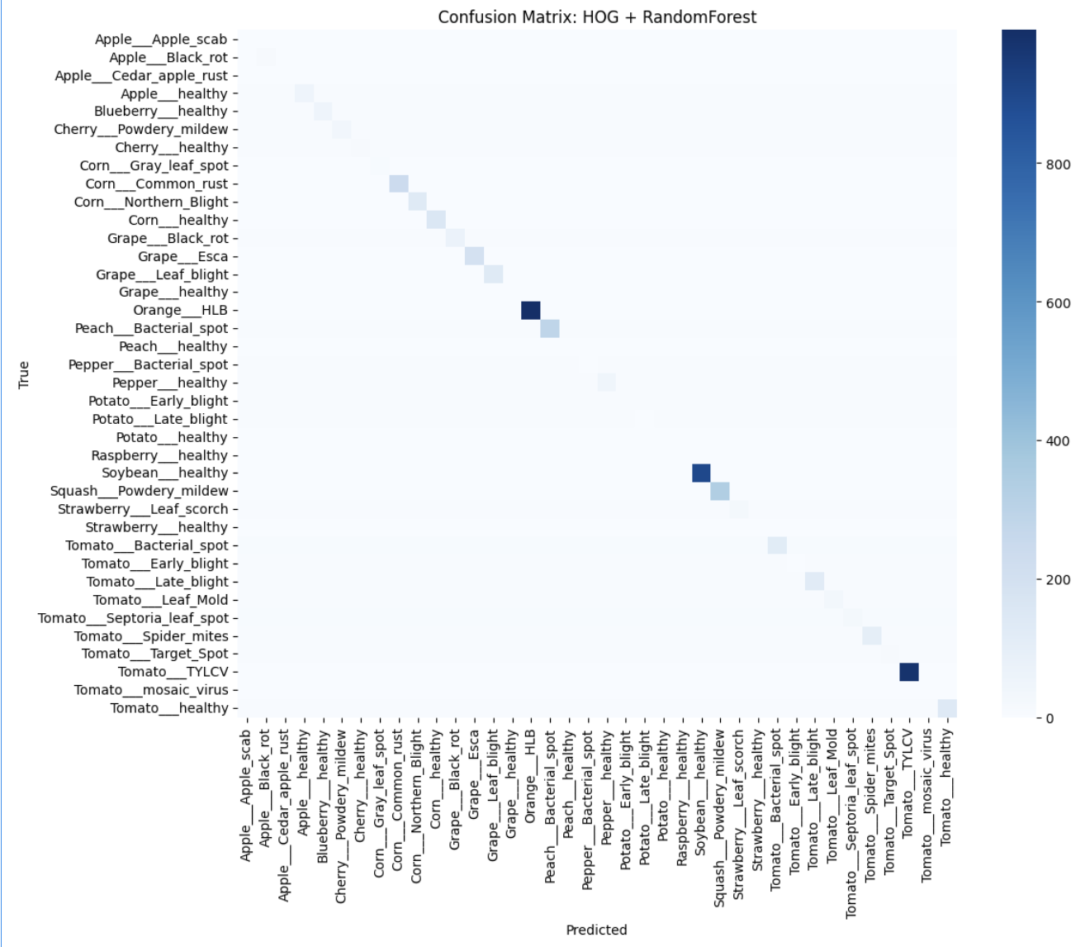  
 **Fig.9.Confusion Matrix HOG + Random Forest**

The model shows **~47.9% accuracy**, **weighted F1 ~0.48**, and **Cohen’s Kappa ~0.44**, indicating moderate agreement but weak overall classification strength.

**5.2. Local Binary Patterns**

**A) Logistic Regression**

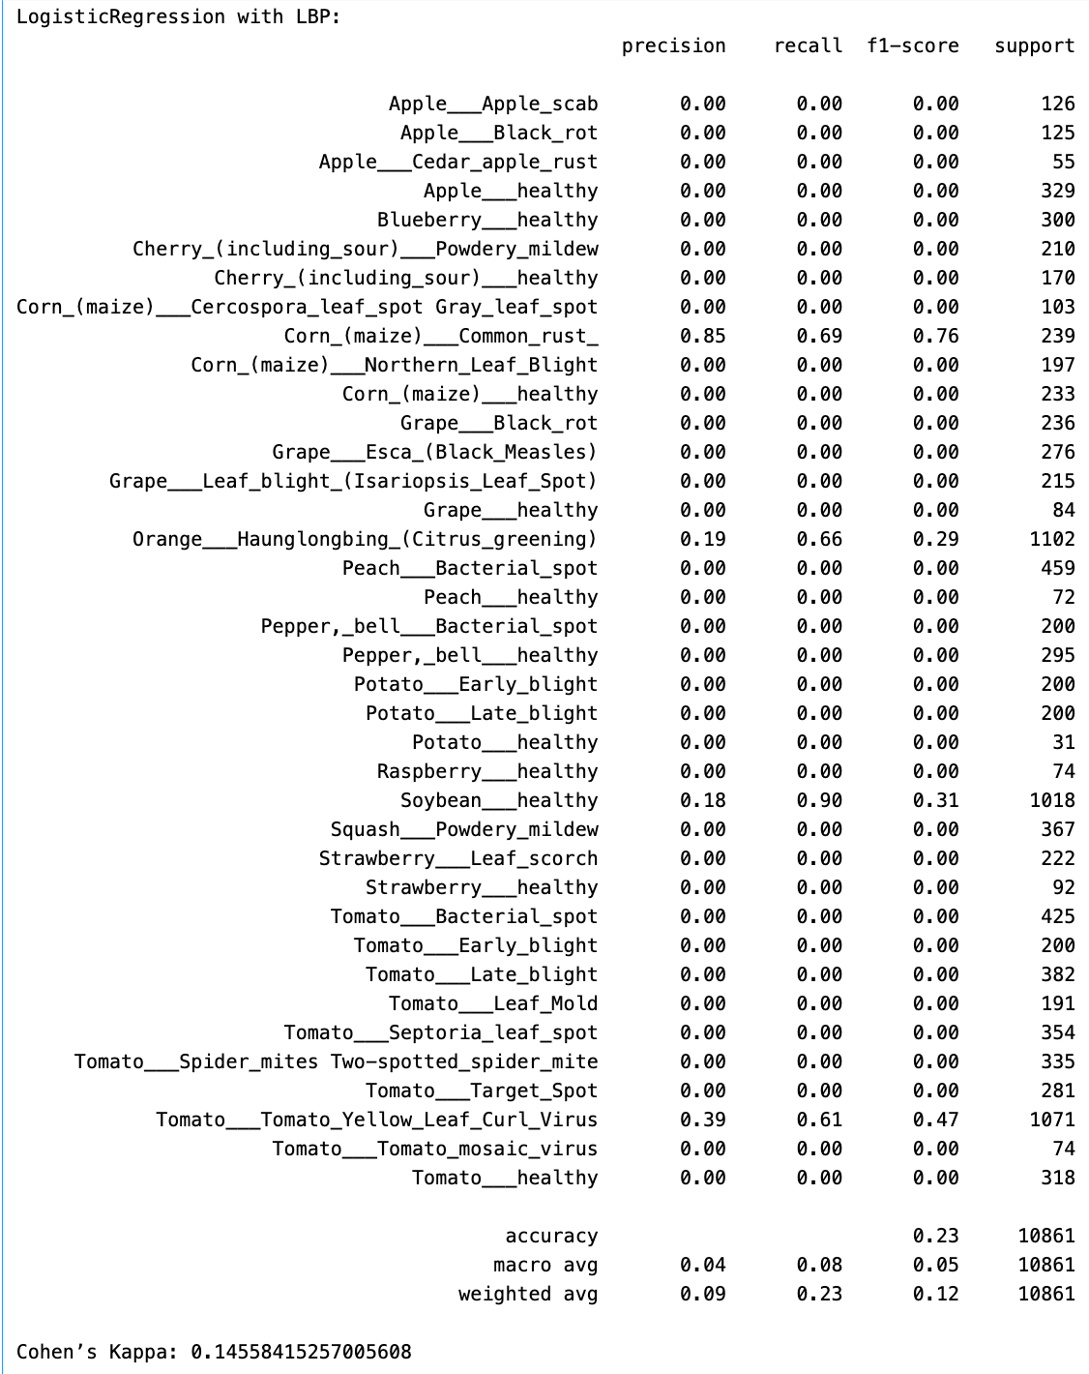**Fig.10. Evaluation metrics of LBP +Logistic- Regression**

**Confusion Matrix:**

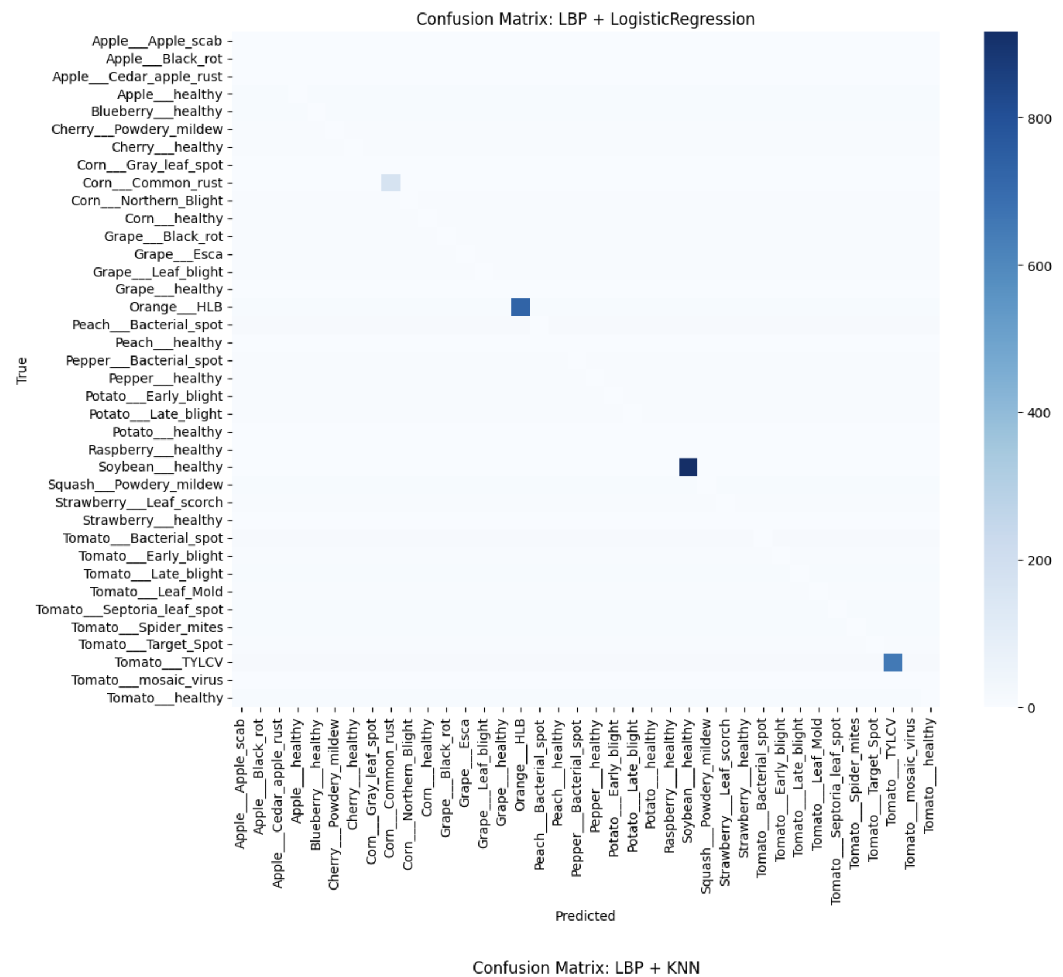

**Fig.11. Evaluation metrics of LBP+KNN**

The model is **extremely weak**, with **22.7% accuracy**, **Macro F1 0.04**, and **Kappa 0.146**. Predictions are biased toward healthy classes, while most disease categories show near-zero precision and recall. Overall, Logistic Regression with LBP features collapses to a few classes, failing to capture complex disease patterns.

**B) KNN**

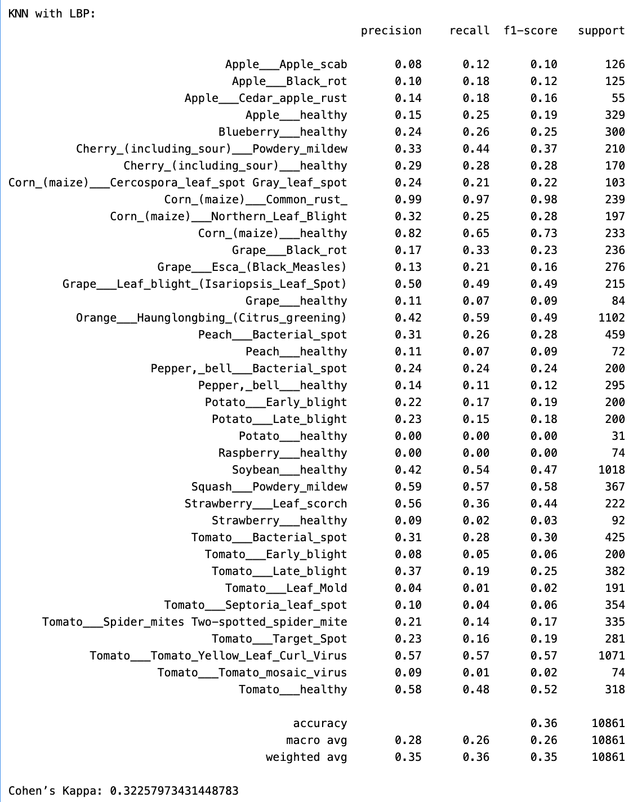  
**Fig.12.Evaluation Metrics of LBP+KNN**

**Confusion Matrix:**

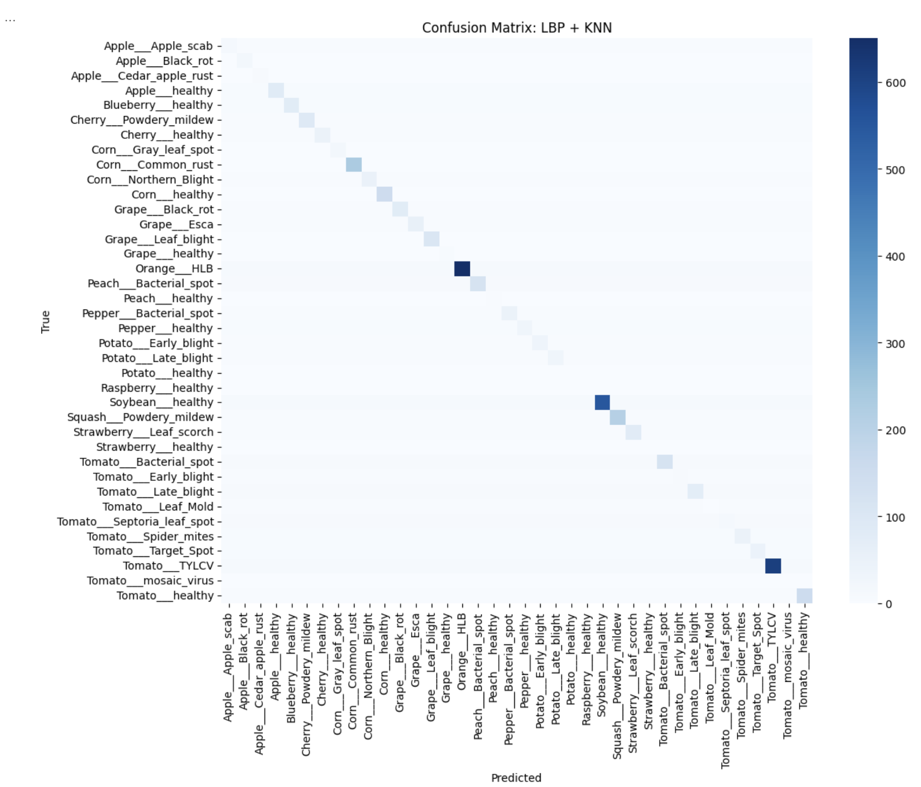

**. Fig.13. Confusion Matrix of LBP+KNN**

The model shows **very poor performance** with **24% accuracy**, **F1 0.24**, and **Kappa 0.20**. It performs well only for Corn rust (F1 0.91), Citrus greening (F1 0.53), and Soybean healthy (F1 0.42), but severely overfits, recognizing only these distinct classes while most others have F1 ≤ 0.10.

**C) Decision Tree**  
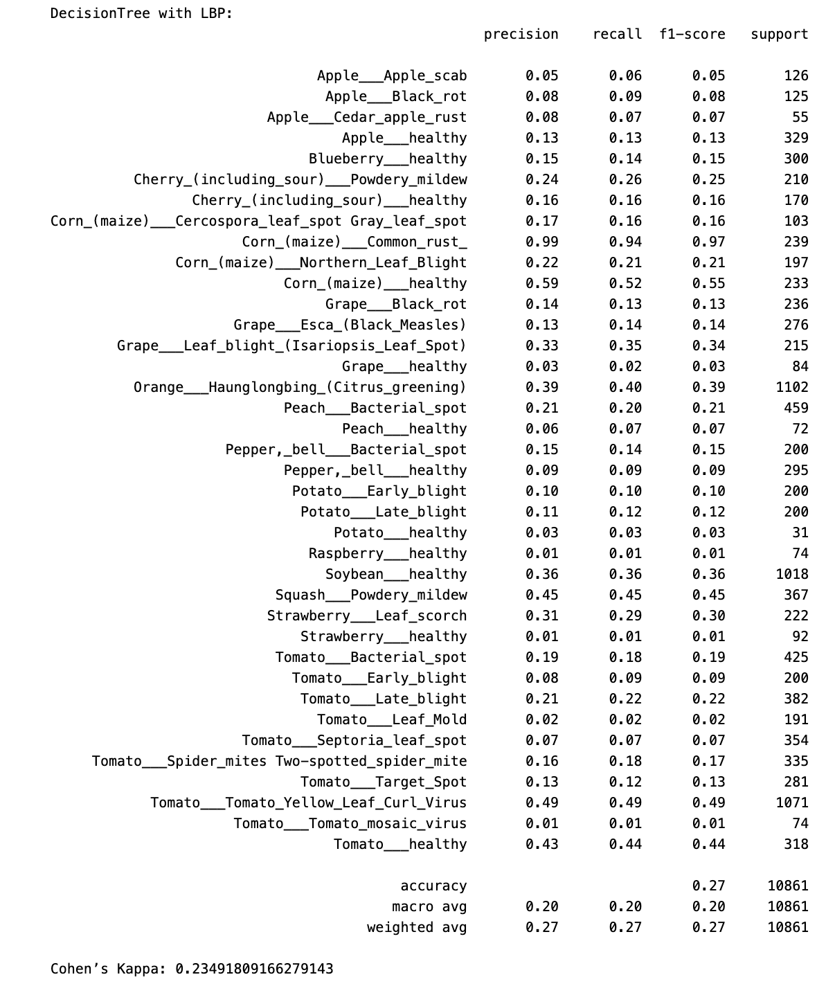  
 **Fig.14. Evaluation metrics of LBP +Decision Tree**  
  
  
**Confusion Matrix:** 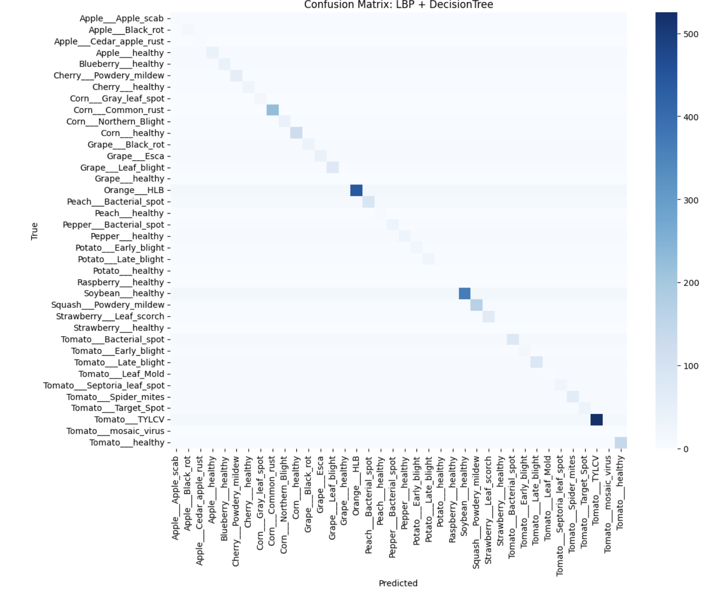

**Fig.15. Confusion Matrix of LBP +Decision Tree**

The model shows **weak overall performance** with **~27% accuracy**, **Macro F1 ~0.20**, and **Kappa 0.235**, only slightly better than Logistic Regression with LBP. It performs well for Corn rust (F1 0.97) and moderately for Soybean healthy and Squash powdery mildew (F1 ~0.36–0.45), but overfits to these distinct classes, leaving most others—including healthy categories—with near-zero F1.

**D) Random Forest**   
  
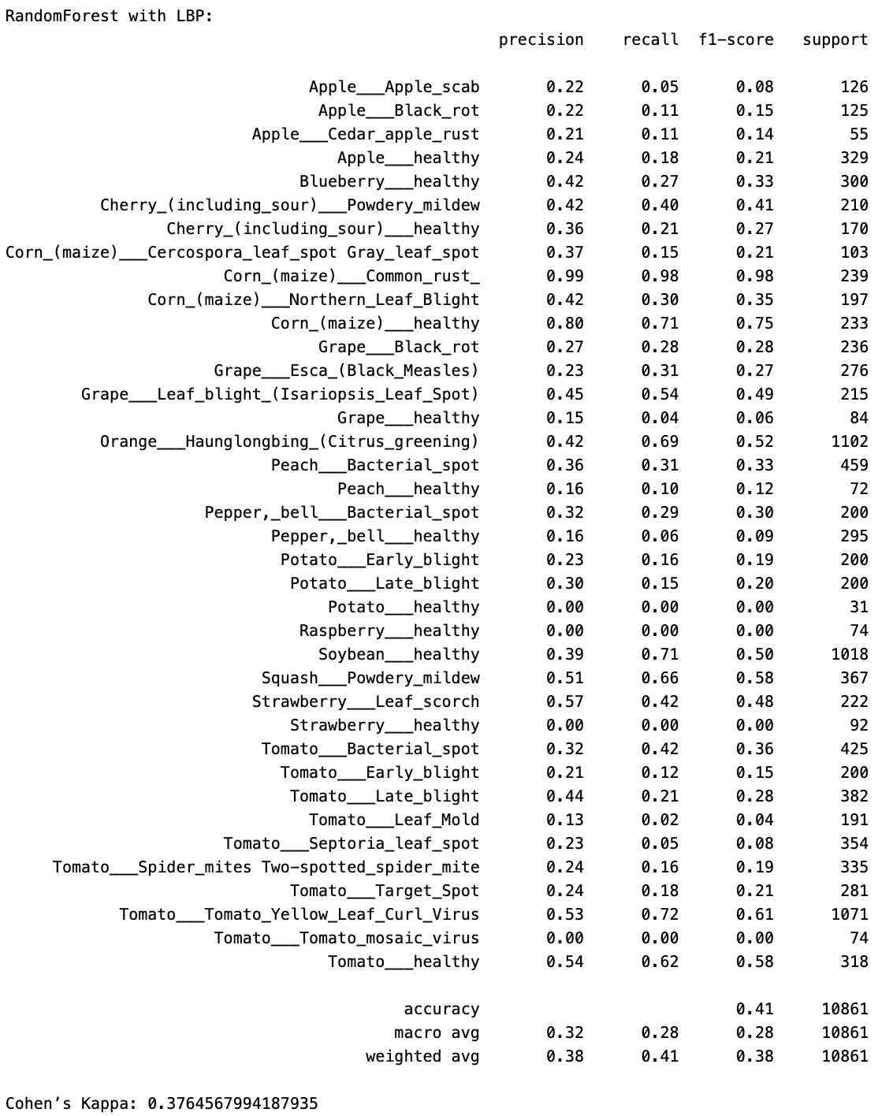

**Fig.16.Evaluation metrics of LBP + Random Forest**

**Confusion Matrix:**

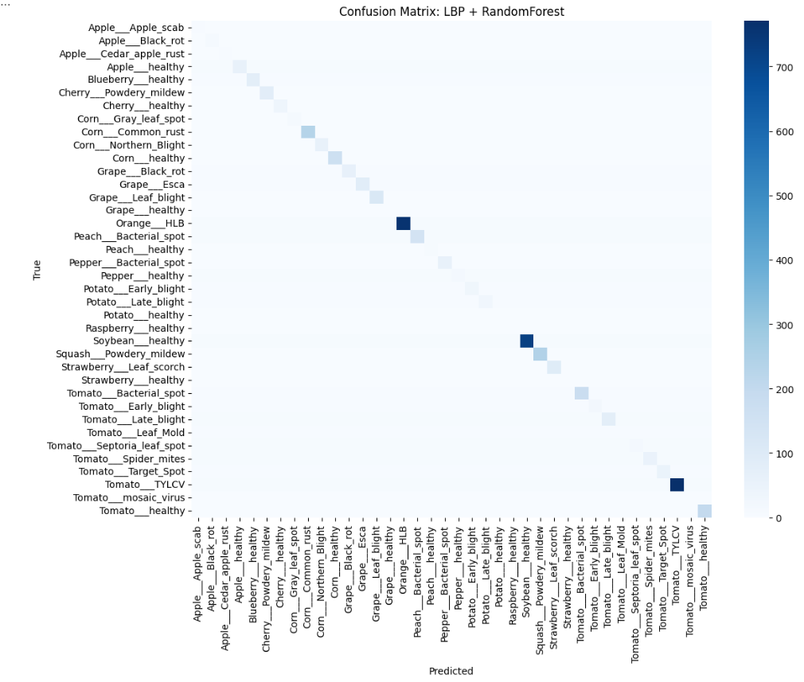

**Fig.17.Confusion matrix of LBP + Random Forest**

The model achieved **~41% accuracy**, **Macro F1 ~0.32**, **Weighted F1 ~0.38**, and **Kappa 0.377**, making it the best among LBP-based models. Strong results were seen for Corn rust (F1 ≈ 0.98), Tomato TYLCV & Soybean healthy (F1 ≈ 0.57–0.72), and Strawberry leaf scorch & Squash powdery mildew (F1 ≈ 0.44–0.57), while Raspberry, Potato, Strawberry healthy and many Tomato diseases (F1 ≈ 0 or <0.2) remained poorly recognized due to LBP feature limits.

**5.3. Edge**

**a) Logistic Regression (LR)**  
  
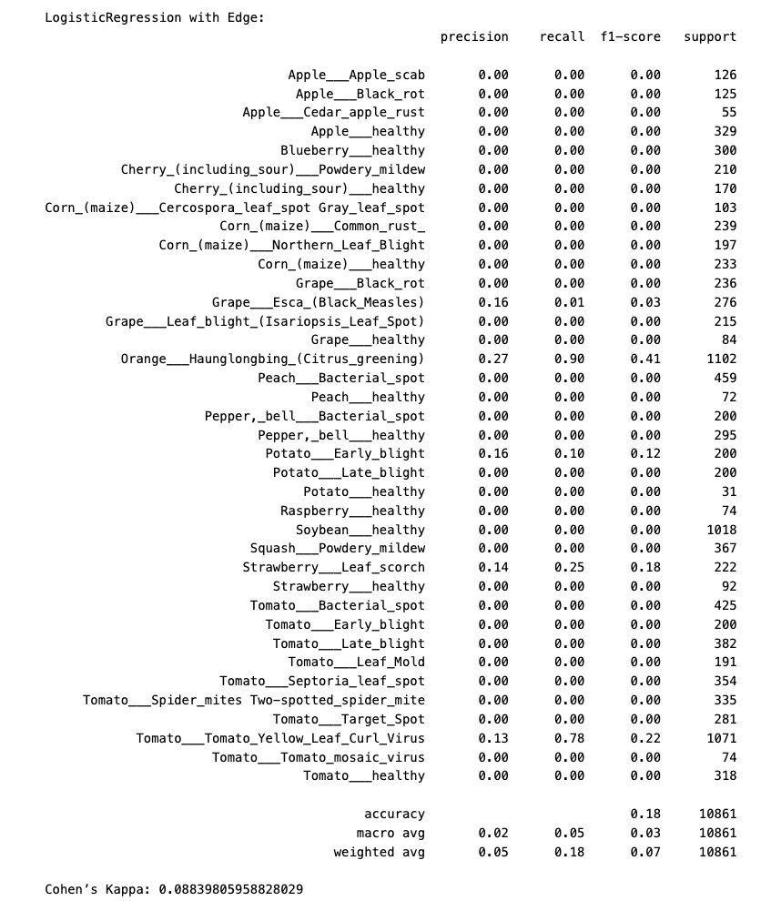

**Fig.18. Evaluation metrics of Edge+ Logistic Regression**

**Confusion Matrix:**

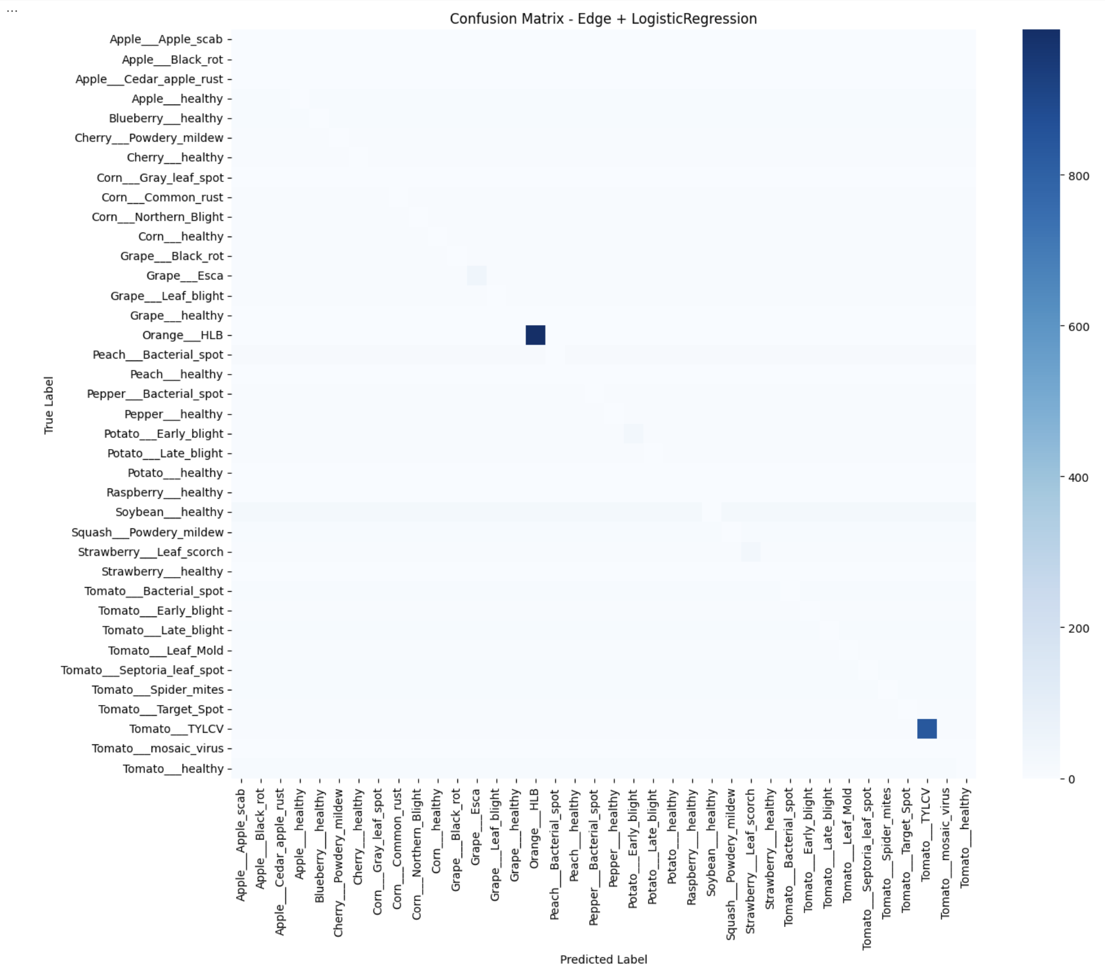  
  
 **Fig.19. Confusion Matrix using EDGE (LR)**

The model delivered **extremely poor performance** with **~18% accuracy**, **Macro F1 ~0.05**, and **Kappa ~0.088**, indicating nearly random predictions. Only Citrus greening (F1 0.41) and Tomato TYLCV (F1 0.22) showed slightly better recognition, while most classes recorded F1 = 0, confirming the model’s failure to generalize beyond a few visually distinct diseases.

**B) KNN with Edge**  
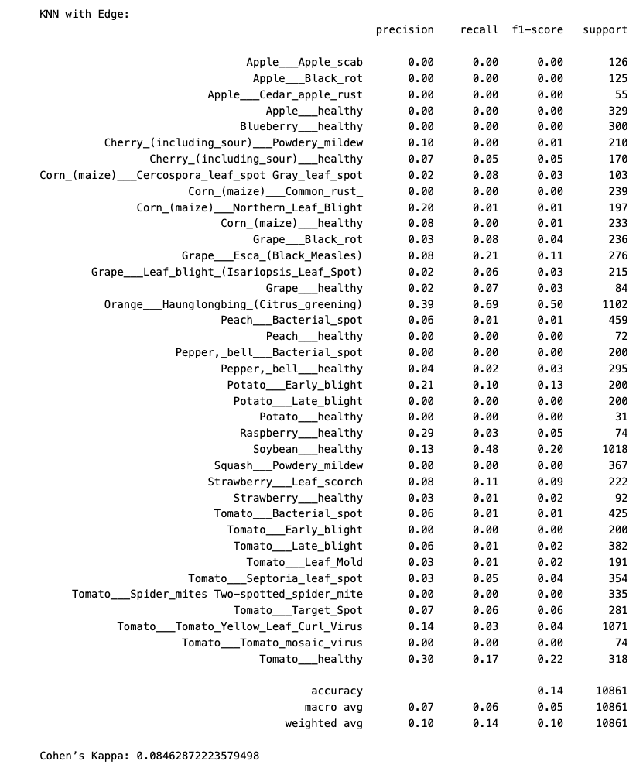  
 **Fig.20. Evaluation metrics of Edge + KNN**

**Confusion Matrix:**

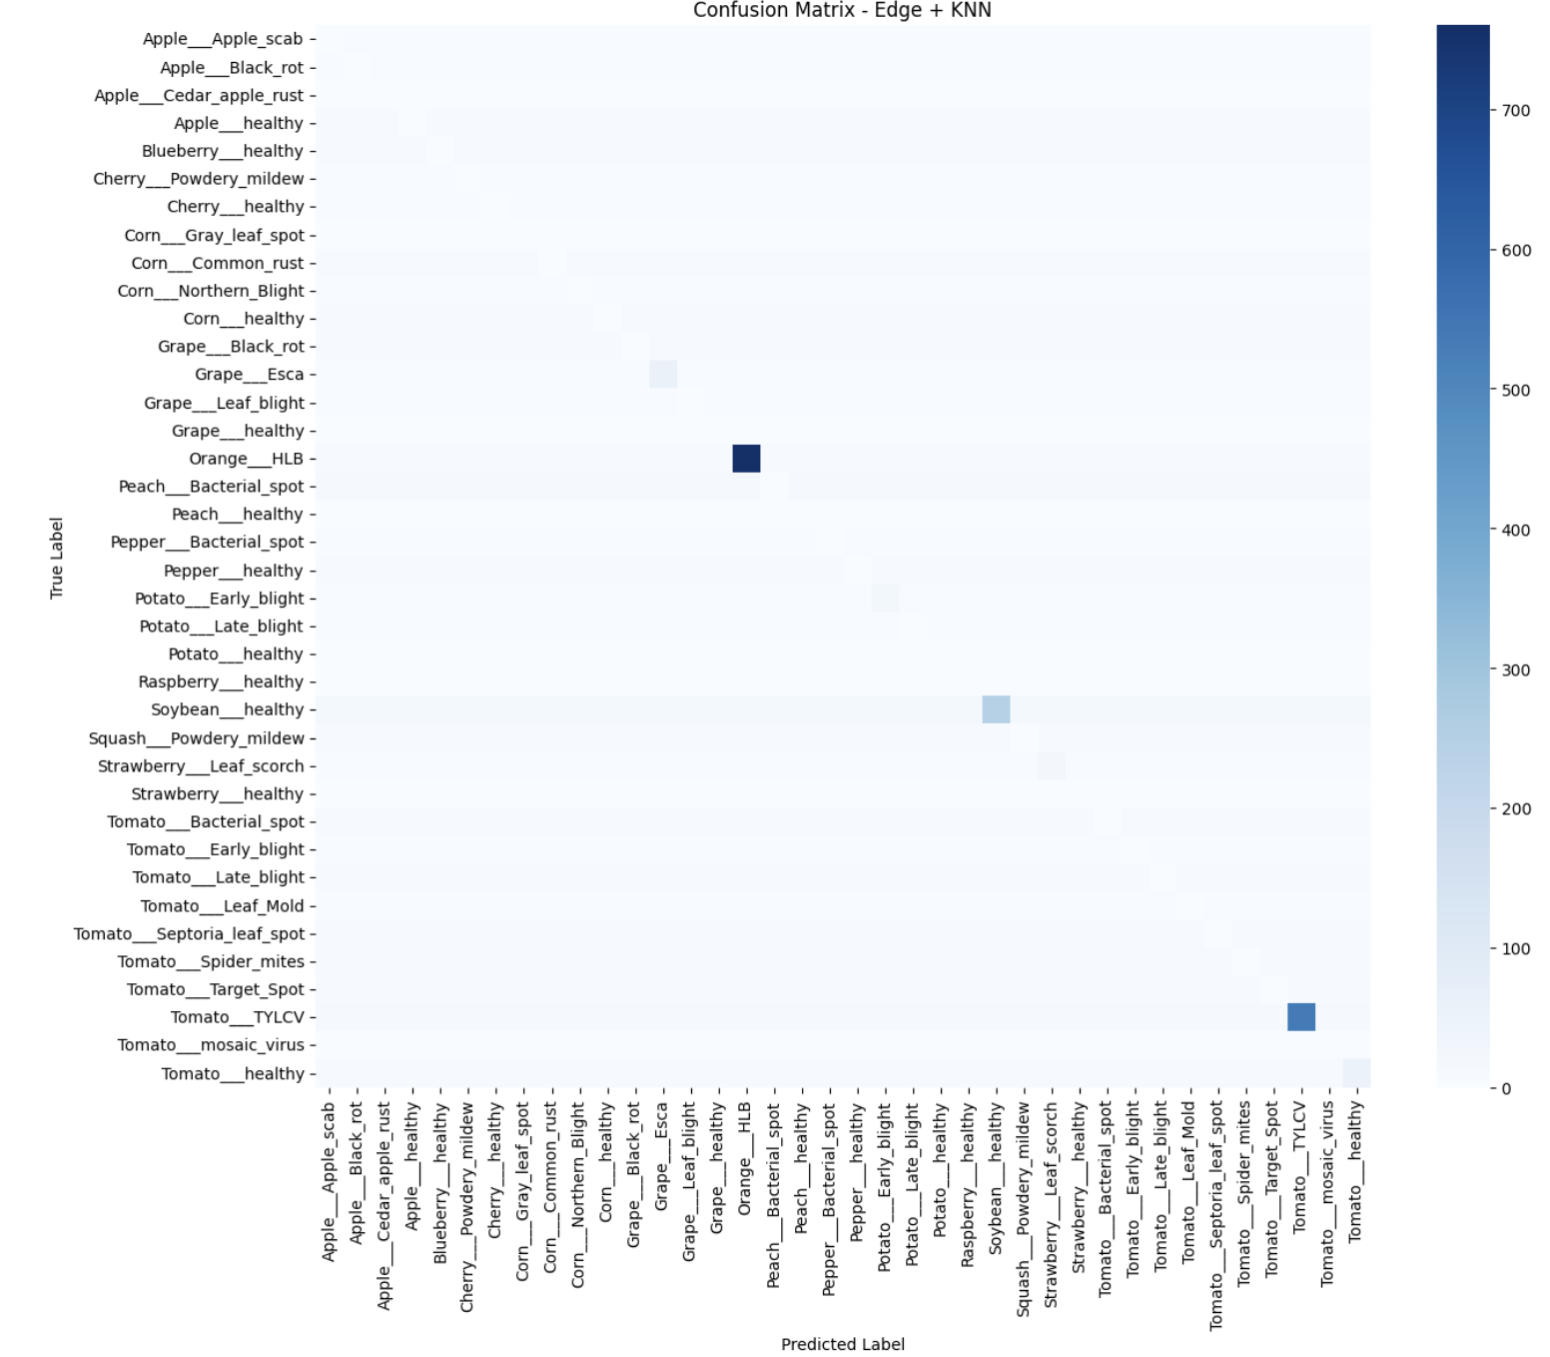 **. Fig.21. Confusion Matrix using EDGE (KNN)**

The model shows **extremely poor performance** with **~14% accuracy**, **Macro F1 ~0.06**, and **Kappa ~0.085**, performing even worse than Edge + Logistic Regression. Almost all classes have near-zero precision, recall, and F1, confirming that edge-based features fail to capture discriminative patterns. Only Orange HLB (F1 0.44) and Tomato Healthy (F1 0.22) show slightly better recognition, while the confusion matrix reveals predictions concentrated in these few classes, with a sparse diagonal indicating severe misclassification across the dataset.

**C) Decision Tree with Edge**   
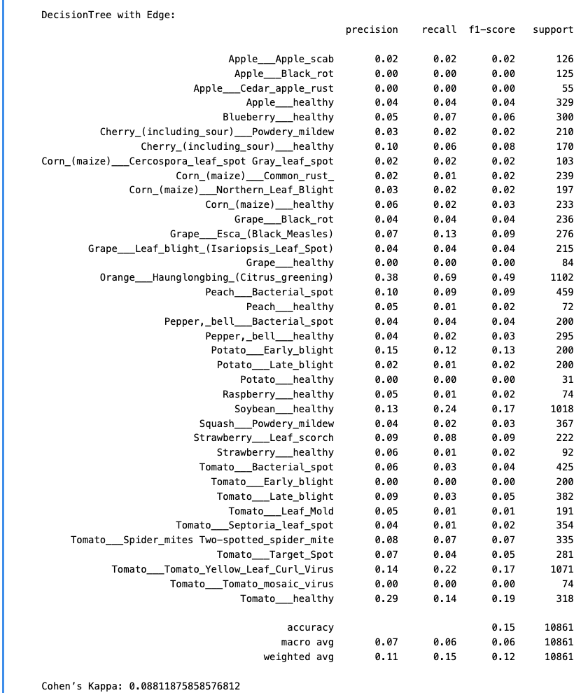  
 **Fig.22. Evaluation metrics of Edge + Decision Tree**

**Confusion Matrix:**

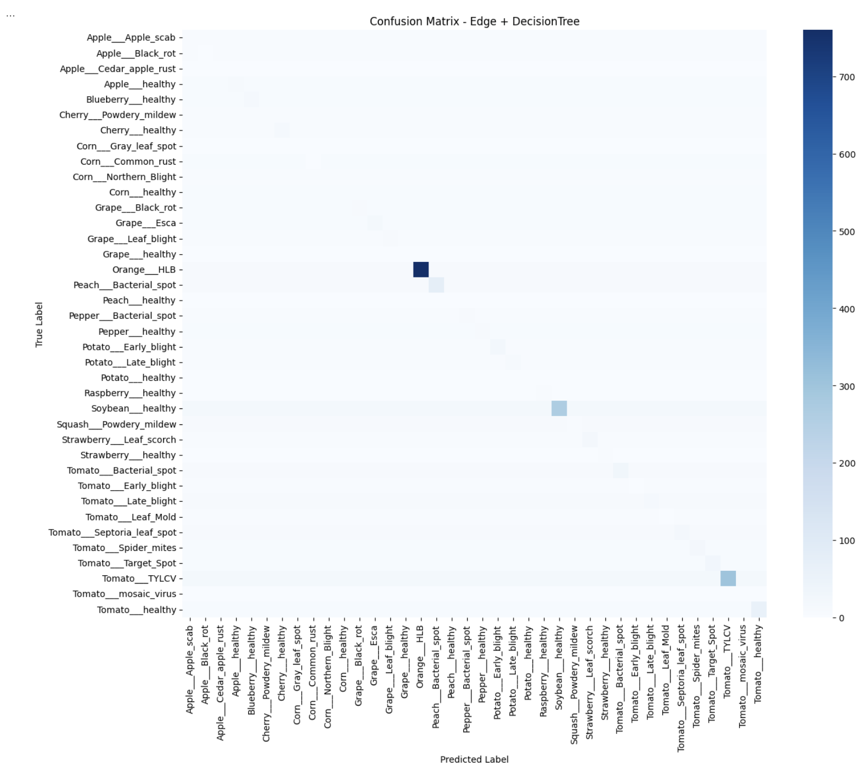 **Fig.23. Confusion Matrix using EDGE+ (DT)**

The model shows extremely poor performance with **~15% accuracy,** **Macro F1 ~0.06,** and **Kappa 0.088**, indicating near-random classification. It performs slightly better for Orange HLB (F1 0.49) and Soybean Healthy (F1 ~0.40), with Tomato Healthy (F1 ~0.19) weakly recognized, while most other classes—like Potato diseases, Raspberry Healthy, and Tomato Leaf Mold—have F1 ≈ 0, reflecting widespread misclassification. Predictions collapse onto a few recognizable categories, and the confusion matrix shows a sparse diagonal, confirming poor generalization. Among all tested models, this Decision Tree with edge-based features is the weakest, even worse than Logistic Regression with LBP (~23% accuracy) and Decision Tree with LBP (~27%), highlighting the need for richer texture or deep-learning features (e.g., CNN embeddings) and stronger ensemble methods for meaningful improvement.

**D) Random Forest**

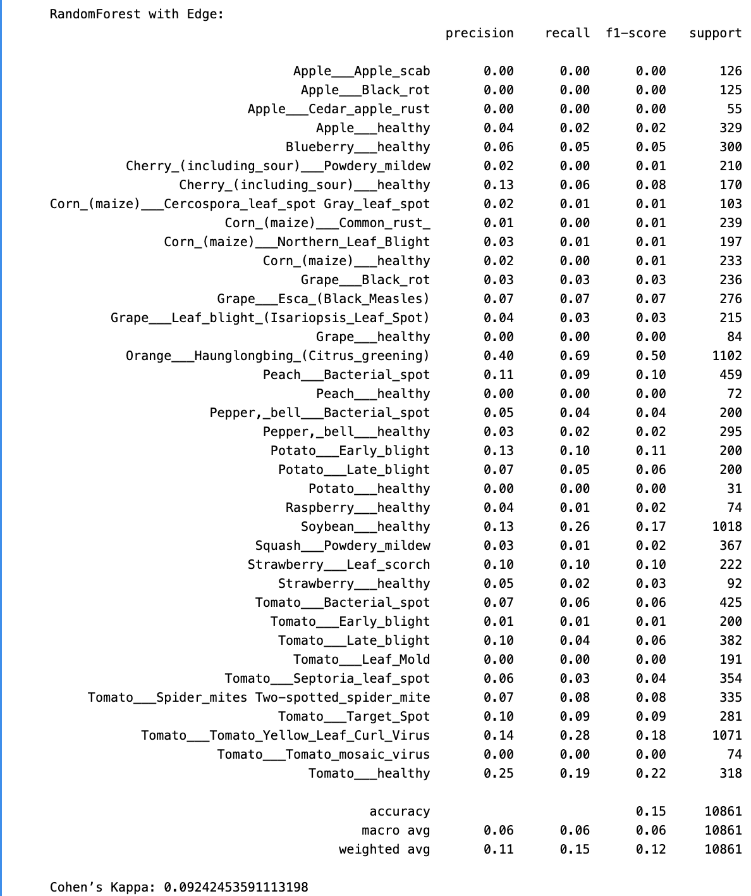

**Fig.24. Evaluation Metrics Edge + Random Forest**

**Confusion Matrix:**  
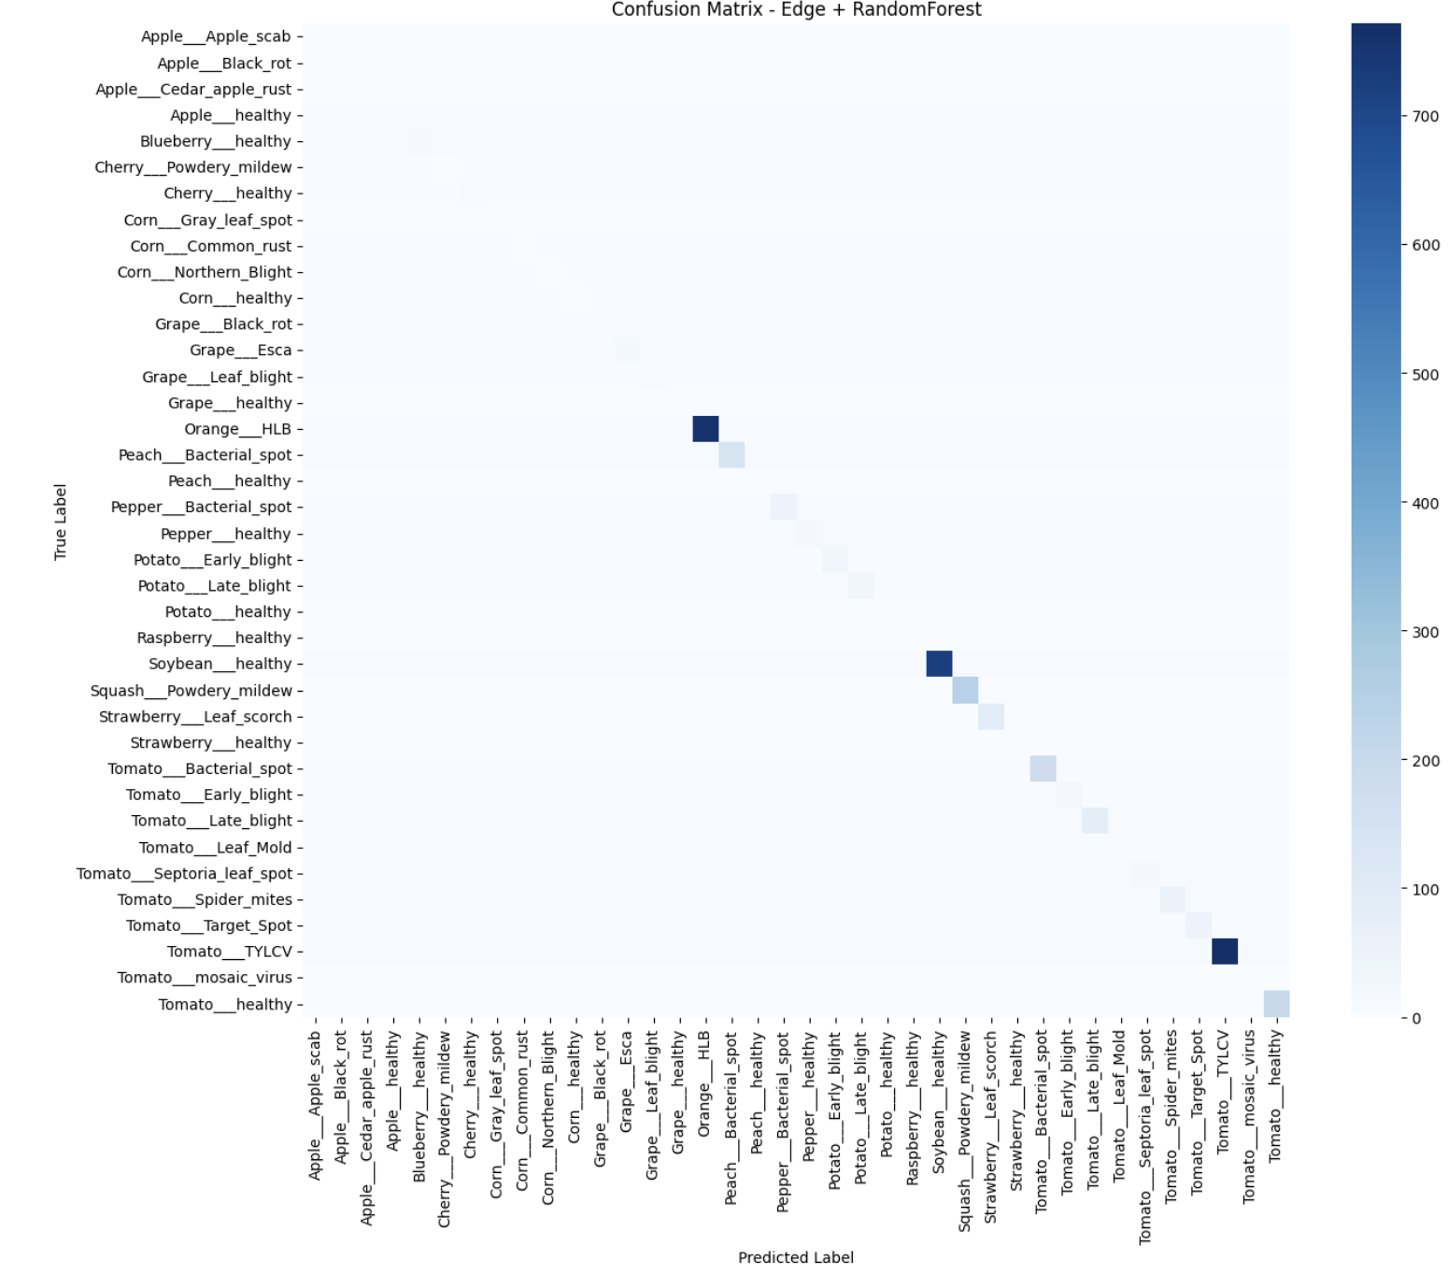

**Fig.25. Confusion Matrix of Edge + Random Forest**

The model delivered **very poor performance** with **~15% accuracy**, **Macro F1 ~0.06**, and **Kappa ~0.092**, showing no meaningful improvement over the Decision Tree. Only Orange HLB (F1 ≈ 0.50) showed strong recognition, while Soybean Healthy (F1 ≈ 0.27) and Tomato Healthy (F1 ≈ 0.22) were weakly identified. Most categories—including Potato, Raspberry, Apple, and Grape diseases—recorded F1 near zero, indicating almost total misclassification. Predictions collapsed into just three classes, and the confusion matrix showed diagonal hotspots only for these, confirming that edge-based features cannot handle diverse plant disease patterns and that this model performs far worse than LBP- or HOG-based classifiers.

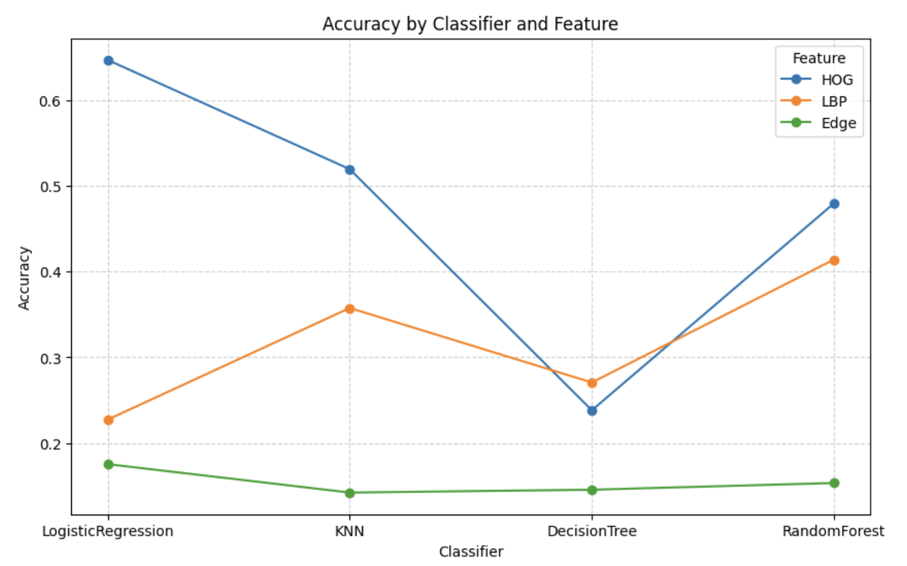 **Fig.26. Accuracy by Classifier and feature**   
  
  
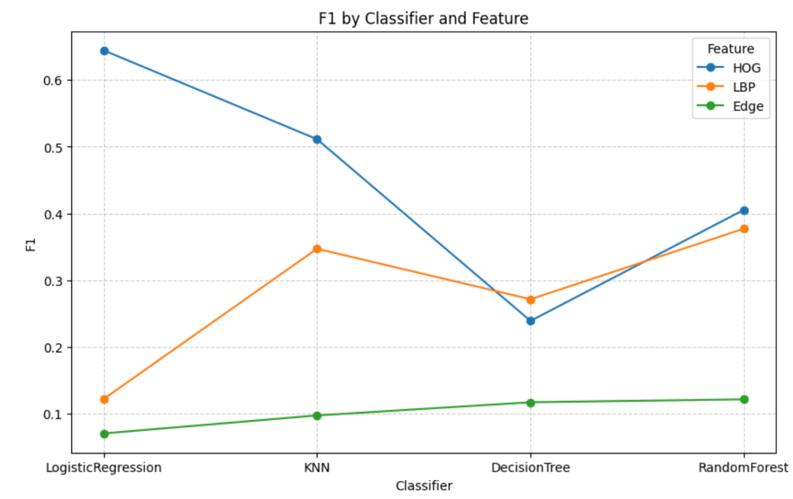  
 **Fig.27. F1 by Classifier & Feature**   
  
  
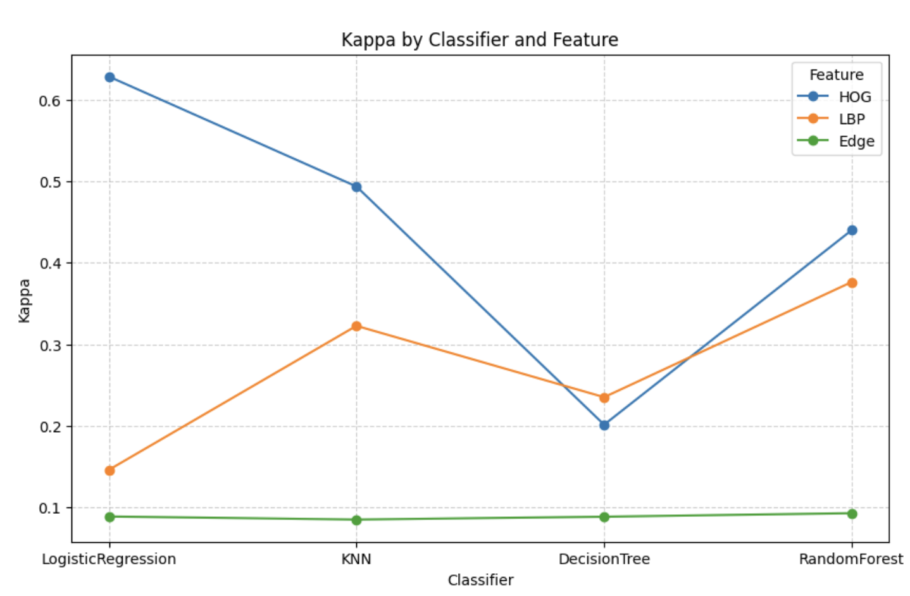  
 **Fig.28. Kappa by Classifier and Feature**

**5.4. Deep Learning Models using classifiers**

To evaluate the effectiveness of deep feature extraction for plant disease classification, three widely used convolutional neural network (CNN) architectures were employed as backbones: ResNet50, MobileNetV2, and VGG16. These pre-trained models were used to extract discriminative feature representations from the Plant Village dataset, which were then passed into traditional classifiers such as Logistic Regression, KNN, Decision Tree, and Random Forest for final classification.

**ResNet50:**  
ResNet50 (Residual Network, 50 layers) leverages residual connections (skip connections) to mitigate vanishing gradient problems in very deep networks. This allows it to learn highly abstract and hierarchical features, making it effective at capturing complex disease patterns. However, in this study, ResNet50 achieved moderate performance (Accuracy ~54%) compared to other deep learning backbones, with higher computation times.

**MobileNetV2:**  
MobileNetV2 is designed as a lightweight and efficient model optimized for mobile and embedded vision applications. It uses depth wise separable convolutions and inverted residuals to reduce computational cost while maintaining strong feature extraction capability. In this study, MobileNetV2 achieved the highest performance across all metrics, with Logistic Regression yielding nearly 95% accuracy and Cohen’s Kappa of ~0.95, making it the most effective backbone for plant disease classification.

**VGG16:**

VGG16 is a classic CNN with 16 layers that stacks small 3×3 convolution filters, known for its simplicity and effectiveness. Although computationally heavier than MobileNet, VGG16 performed strongly, achieving over 91% accuracy with Logistic Regression and ~0.91 Kappa. This confirms its strength in extracting texture and structural features relevant to leaf diseases.  
  
  
  
  
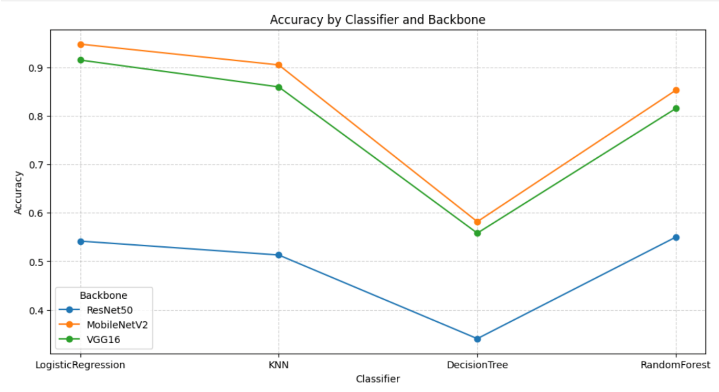 **Fig.29. Accuracy of Classifier and Backbone**

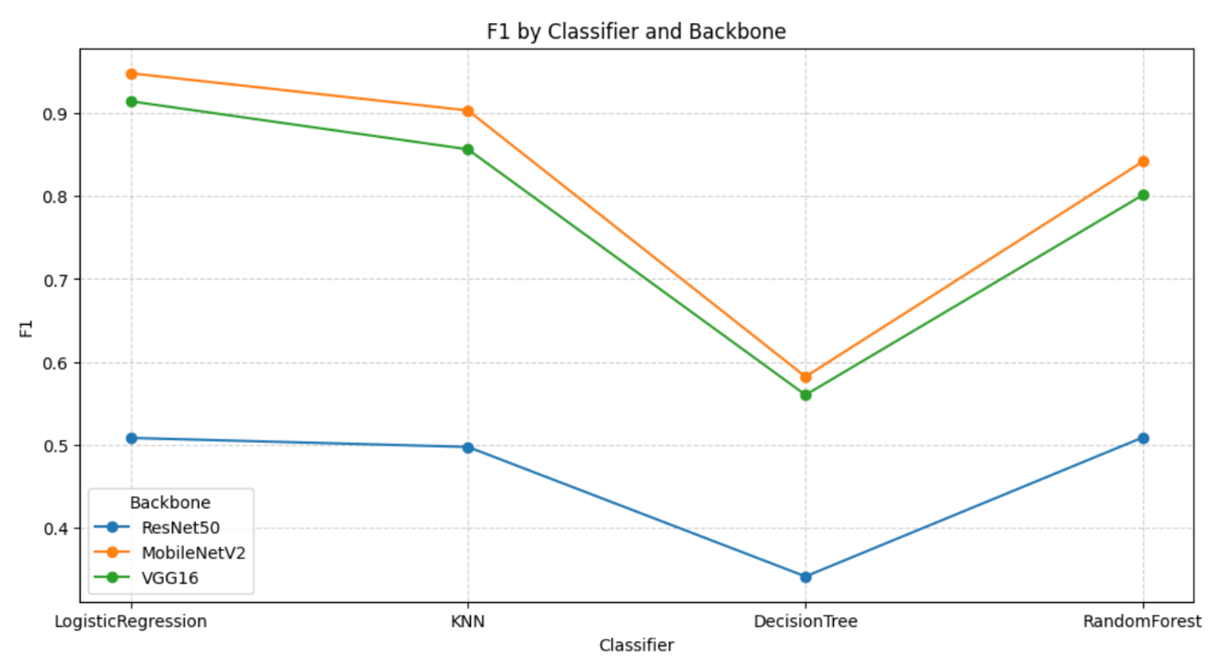

**Fig.30. F1 Score by Classifier and Backbone**  
  
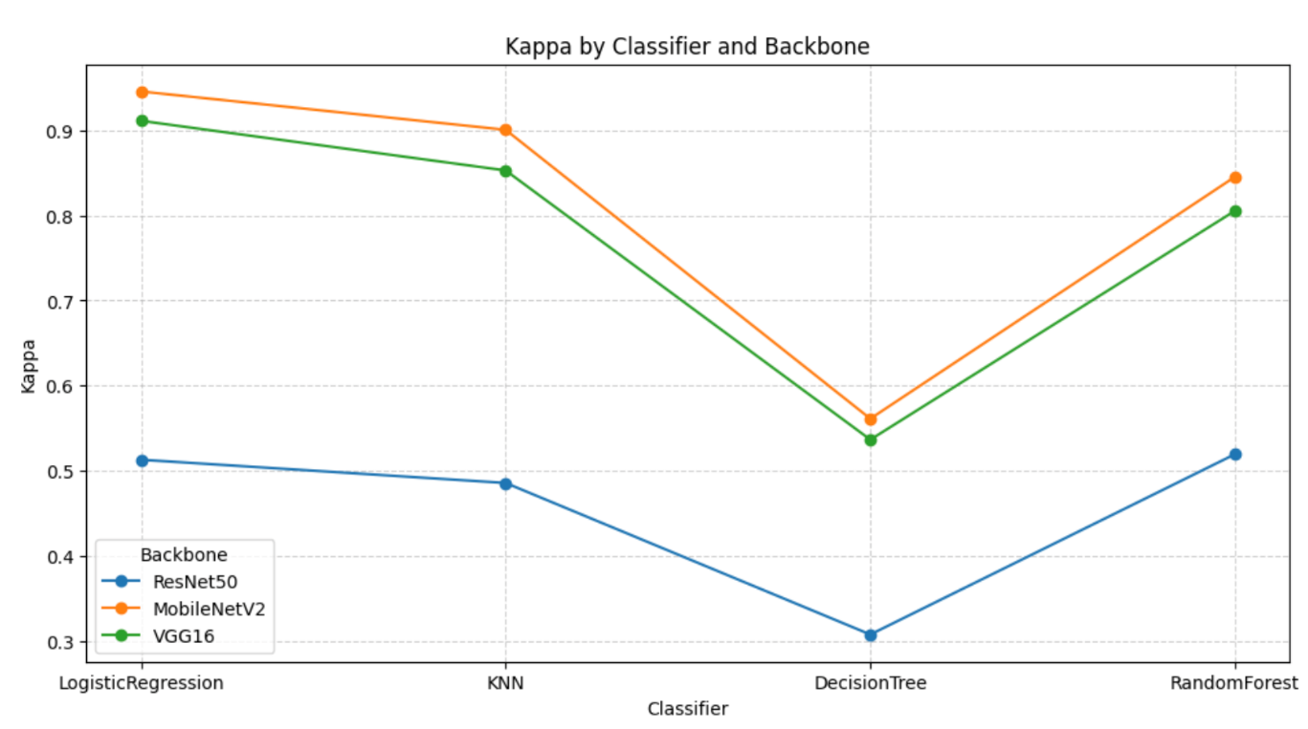  
**Fig.31. Kappa by classifier and Backbone**

**6. ANALYSIS**

**6.1. Comparison of the results obtained**

**6.1.1. Comparative Analysis of Traditional Feature Extraction Methods with Classifiers**  
This table presents a comparative analysis of three Traditional feature extraction methods—Histogram of Oriented Gradients (HOG), Local Binary

Patterns (LBP), and Edge Detection—evaluated using multiple classifiers. The performance is reported in terms of Cohen’s Kappa, F1-score, and Accuracy, providing a holistic view of both predictive power and class-wise agreement.

Overall, HOG emerges as the most reliable feature representation, achieving the highest scores across all three metrics, particularly with Logistic Regression (Kappa ≈ 0.63, F1 ≈ 0.64, Accuracy ≈ 0.65). LBP shows moderate performance, especially with Random Forest (Kappa ≈ 0.38, F1 ≈ 0.38, Accuracy ≈ 0.41), while Logistic Regression and Decision Trees perform poorly on this feature type. Edge Detection exhibits the weakest performance, with uniformly low values across classifiers (Kappa ≤ 0.09, Accuracy ≤ 0.15), indicating limited discriminative capability.

|  |  |  |  |  |
| --- | --- | --- | --- | --- |
| **Feature** | **Kappa** | **F1** | **Accuracy** | **Classifier** |
| **HOG** | 0.628844 | 0.64455 | 0.64681 | LogisticRegression |
| **HOG** | 0.493746 | 0.511239 | 0.519381 | KNN |
| **HOG** | 0.20114 | 0.238777 | 0.238284 | Decision Tree |
| **HOG** | 0.440218 | 0.40538 | 0.479606 | Random Forest |
| **LBP** | 0.145584 | 0.121607 | 0.227327 | LogisticRegression |
| **LBP** | 0.32258 | 0.347017 | 0.357518 | KNN |
| **LBP** | 0.234918 | 0.271308 | 0.270693 | DecisionTree |
| **LBP** | 0.376457 | 0.377102 | 0.41405 | Random Forest |
| **Edge** | 0.088398 | 0.070067 | 0.17549 | LogisticRegression |
| **Edge** | 0.084629 | 0.09707 | 0.142344 | KNN |
| **Edge** | 0.088119 | 0.116805 | 0.145659 | Decision Tree |
| **Edge** | 0.092425 | 0.121167 | 0.153485 | Random Forest |

**Table 1. Comparison of Traditional Feature Extraction Methods with Classifiers**

**6.1.2. Performance analysis of Traditional Models**  
This table presents a comparative analysis of three Traditional feature extraction methods—Histogram of Oriented Gradients (HOG), Local Binary Patterns (LBP), and Edge Detection—evaluated using multiple classifiers. The performance is reported in terms of Cohen’s Kappa, F1-score, and Accuracy, providing a holistic view of both predictive power and class-wise agreement.

Overall, HOG emerges as the most reliable feature representation, achieving the highest scores across all three metrics, particularly with Logistic Regression (Kappa ≈ 0.63, F1 ≈ 0.64, Accuracy ≈ 0.65). LBP shows moderate performance, especially with Random Forest (Kappa ≈ 0.38, F1 ≈ 0.38, Accuracy ≈ 0.41), while Logistic Regression and Decision Trees perform poorly on this feature type. Edge Detection exhibits the weakest performance, with uniformly low values across classifiers (Kappa ≤ 0.09, Accuracy ≤ 0.15), indicating limited discriminative capability.

These findings reaffirm that while traditional handcrafted features can offer some predictive utility (notably HOG), their performance is significantly limited compared to modern deep learning features such as ResNet, which typically achieve superior results across all evaluation metrics.

**6.1.3. Comparative Analysis of Deep Learning Models using classifiers**

|  |  |  |  |  |  |  |
| --- | --- | --- | --- | --- | --- | --- |
| **Backbone** | **Classifier** | **Accuracy** | **Precision** | **Recall** | **F1** | **Kappa** |
| **ResNet50** | **LogisticRegression** | **0.541755** | **0.518869** | **0.541755** | **0.508139** | **0.513122** |
| **ResNet50** | **KNN** | **0.513028** | **0.514117** | **0.513028** | **0.497258** | **0.485815** |
| **ResNet50** | **Decision Tree** | **0.340392** | **0.342272** | **0.340392** | **0.340965** | **0.307782** |
| **ResNet50** | **RandomForest** | **0.550041** | **0.562335** | **0.550041** | **0.508188** | **0.519624** |
| **MobileNetV2** | **LogisticRegression** | **0.948255** | **0.948322** | **0.948255** | **0.948193** | **0.945725** |
| **MobileNetV2** | **KNN** | **0.905349** | **0.908134** | **0.905349** | **0.903301** | **0.900634** |
| **MobileNetV2** | **DecisionTree** | **0.581806** | **0.5829** | **0.581806** | **0.582001** | **0.561288** |
| **MobileNetV2** | **RandomForest** | **0.853236** | **0.852431** | **0.853236** | **0.841776** | **0.845501** |
| **VGG16** | **LogisticRegression** | **0.915385** | **0.914505** | **0.915385** | **0.914352** | **0.911213** |
| **VGG16** | **KNN** | **0.859958** | **0.86308** | **0.859958** | **0.856363** | **0.8529** |
| **VGG16** | **DecisionTree** | **0.558144** | **0.562553** | **0.558144** | **0.560008** | **0.536669** |
| **VGG16** | **RandomForest** | **0.815487** | **0.81915** | **0.815487** | **0.801399** | **0.805569** |

**Table 2. Comparison of Deep learning Models with Classifiers**

**6.1.4. Performance analysis of Deep Learning Models**

On the PlantVillage dataset, MobileNetV2 emerged as the best-performing extractor, achieving 94.8% accuracy, 0.95 F1-score, and 0.945 Kappa. Its lightweight yet powerful architecture makes it highly suitable for practical deployment, particularly in real-time and edge scenarios where efficiency is critical. VGG16 followed with 91.5% accuracy, 0.91 F1, and 0.911 Kappa, offering strong feature representation but at the cost of higher computational demand, making it more appropriate for research or high-performance environments. ResNet50, in contrast, underperformed with only 54–55% accuracy and ~0.51 F1/Kappa, reflecting its reliance on fine-tuning for effective domain adaptation in plant disease classification.

**6.1.5. Trade-offs Between Traditional and Deep Learning-Based Feature Extraction**

|  |  |  |
| --- | --- | --- |
| **Aspect** | **Conventional Features (HOG, LBP, Edge)** | **Deep Learning Features (ResNet50, MobileNetV2, VGG16)** |
| **Feature Representation** | Low-level handcrafted descriptors; fail to capture complex disease textures | Hierarchical, pretrained, capture edges → shapes → textures → semantic structures |
| **Computation Time** | Extremely fast (LBP/Edge in <5s, HOG slightly slower ~2500s with LR) | Slower feature extraction (hundreds of seconds), but reusable |
| **Robustness** | Poor robustness; sensitive to noise, rotation, illumination | Strong robustness; maintain accuracy under varied conditions |
| **Generalization** | Limited generalization, high risk of overfitting | Strong generalization; MobileNetV2 features exceeded 94% accuracy |
| **Accuracy (PlantVillage)** | HOG+LR ~65%, others <50% | MobileNetV2+LR ~95%, VGG16+LR ~91% |
| **Interpretability** | Easy to interpret (edges, textures) | Harder to interpret (“black box” features) |
| **Best Use-case** | Small, resource-constrained tasks | Large-scale, real-world plant disease recognition |

**Table 3. Trade-offs Between Traditional and Deep Learning-Based Feature Extraction**

**6.1.6. Robustness in Traditional Deep Learning Models**

This project evaluated two major categories of image feature extraction and classification on the PlantVillage dataset.

Conventional handcrafted methods (HOG, LBP, Edge Detection). Deep learning–based feature extraction (ResNet50, MobileNetV2, VGG16 as pretrained CNN backbones).

**Traditional Models (HOG, LBP, Edge):**

**HOG:** Among handcrafted methods, HOG combined with Logistic Regression achieved the highest accuracy (64.7%) and a Kappa of 0.62, showing moderate generalization capability. However, performance degraded across other classifiers, especially Decision Trees (~23%). This indicates that while HOG captures edge/orientation information effectively, its robustness is limited when applied to more complex textures such as subtle leaf diseases.

**LBP:** Results were weaker overall (22–41% accuracy). Although computationally efficient (very low training times), LBP failed to capture discriminative features beyond simple local texture patterns. This made it less robust under variations in disease patterns and lighting conditions.

**Edge Detection:** The weakest performer, with accuracy as low as 14–17%, showing it is not suitable for disease classification. Edge-based features were too sensitive to noise and completely missed texture-level differences critical for classification.

**Generalization:** Handcrafted features struggled to generalize across unseen validation data. While HOG showed some stability, both LBP and Edge detection suffered from overfitting and poor robustness under real-world variations.

**6.1.7. Robustness in Deep learning models**

**ResNet50:** Surprisingly, ResNet50 features yielded only moderate results with traditional classifiers (Logistic Regression ~54%, Random Forest ~55%). This suggests that while ResNet50 is powerful in end-to-end CNN training, its global average pooled features may not transfer as effectively to shallow classifiers without fine-tuning. Generalization was limited here, reflected in the relatively low Kappa scores (~0.51).

**MobileNetV2:** Delivered the best overall performance, achieving 94.8% accuracy with Logistic Regression and 90.5% with KNN. Even Random Forest performed strongly (~85.3%). These results show that MobileNetV2 features are compact, highly discriminative, and generalize well. The high Kappa values (>0.90) demonstrate robustness and consistency across classes.

**VGG16:** Also performed well, with Logistic Regression reaching 91.5% accuracy and KNN achieving 85.9%. While not as strong as MobileNetV2, VGG16 demonstrated stable generalization and robustness, outperforming ResNet50 in this hybrid setup.

**Generalization:** MobileNetV2 features exhibited the highest robustness, maintaining high performance across classifiers with relatively low variance. VGG16 was similarly reliable, whereas ResNet50 underperformed, showing that not all deep features generalize equally well when decoupled from their native end-to-end training setups. Discussion on Robustness and Generalization

**6.2. Computational analysis**

**6.2.1. Computational Analysis in Traditional Models**

**HOG (Histogram of Oriented Gradients):**

Execution Time: ~1 hr 42 min (~6300s).

HOG generates high-dimensional descriptors (~54,000 images), making both extraction and training computationally heavy. While more discriminative than LBP or Edge, its large feature size explains the longest runtime.

**LBP (Local Binary Patterns):**

Execution Time: ~10–14 min.  
Produces compact histograms with low-dimensional features, enabling fast training. Its simplicity ensures efficiency but limits discriminative power, resulting in weaker accuracy.

**Edge Detection:**

Execution Time: ~8–14 min.

Uses convolutional filters to produce compact edge maps. Extremely efficient but oversimplified, leading to poor performance despite low runtime.

**6.2.2. Computational Analysis of Deep Learning Feature Extraction**

**ResNet50:**  
Execution Time: ~529s (~9 min).

Efficient due to residual connections, but accuracy was modest (~34–55%), suggesting poor alignment with classical classifiers without fine-tuning.

**MobileNetV2:**  
Execution Time: ~135s (~2 min).

Lightweight design with depthwise separable convolutions enabled the fastest runtime and highest accuracy (~94.8% with Logistic Regression), balancing speed and predictive power.

**VGG16:**  
Execution Time: ~18,305s (~5 hrs).

Heavy architecture (138M parameters) led to very high runtime despite strong accuracy (~91.5%). Suitable for high-performance setups, but impractical in resource-limited environments.

**7. CONCLUSION**

**7.1. Best Performing Methods**

Among the evaluated models, **MobileNetV2 + Logistic Regression** and **VGG16 + Logistic Regression** stood out as the most effective, outperforming both handcrafted features and other deep feature combinations.

**7.1.1 MobileNetV2 + Logistic Regression**

This configuration achieved the highest performance (94.8% accuracy, 0.95 F1, 0.945 Kappa). MobileNetV2’s lightweight architecture, using depthwise separable convolutions and inverted residual blocks, provided highly discriminative features. Logistic Regression effectively separated these features into clear decision boundaries.

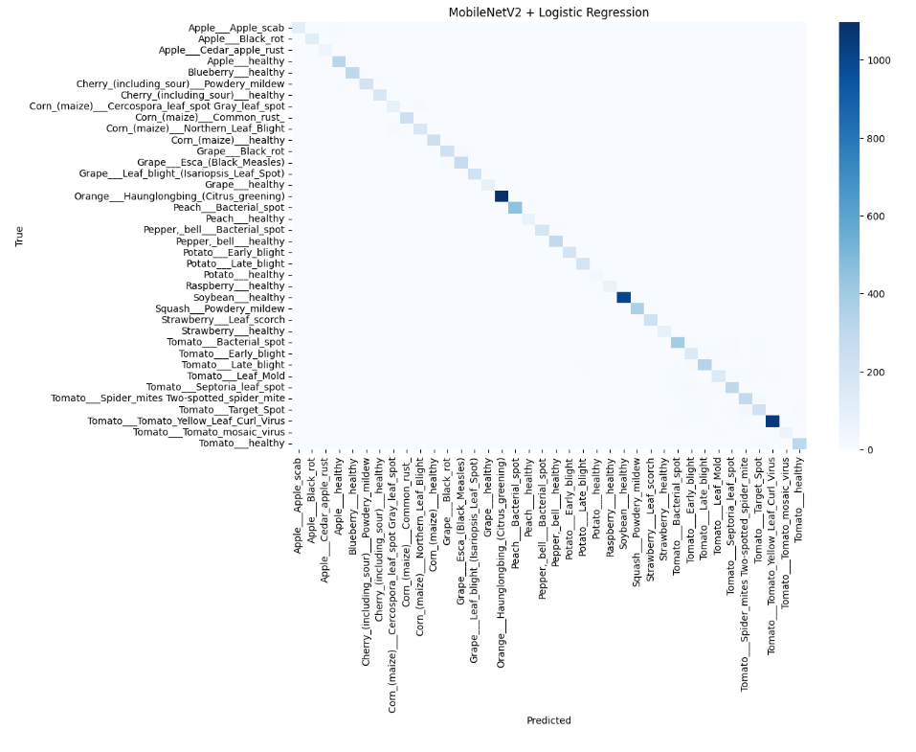

**Fig.32. MobileNet + Logistic Regression**

**7.1.2. VGG16 + Logistic Regression**

The second-best model, VGG16 + Logistic Regression, reached 91.5% accuracy, 0.91 F1, and 0.911 Kappa. While computationally heavier, VGG16 extracted stable feature representations that enabled smooth and generalizable decision boundaries. The confusion matrix also showed clear diagonal dominance, though with slightly higher misclassifications, particularly in visually similar disease classes.

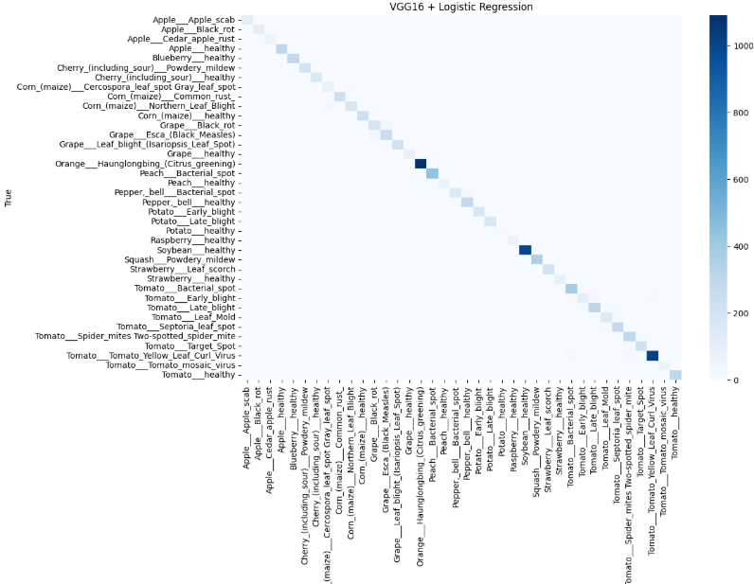

**Fig.33. Confusion Matrix of VGG16+Logistic Regression**

Although **ResNet50** is a modern backbone, its features did not align well with shallow classifiers in this study. Accuracy (~54–55%) remained low without fine-tuning, highlighting that backbone choice is critical for feature transferability.

Overall, **MobileNetV2 + Logistic Regression** emerged as the optimal model, combining high accuracy, robustness, and efficiency. **VGG16 + Logistic Regression** provides a strong alternative when resources allow. Both significantly outperformed handcrafted approaches (HOG, LBP, Edge), where even the strongest (HOG + Logistic Regression) reached only ~65% accuracy. This confirms that **deep CNN features are far more effective and reliable** for multi-class, fine-grained plant disease classification.

## **References**

1. S. Pal, *et al.*, “Machine Learning Based Pattern Recognition with HOG Features for Detection of Islanding,” in *Proc. IEEE ICEPES*, 2024.
2. S. Pal, *et al.*, “Decision Tree Based Method for Detecting Islanding using Pattern Recognition with HOG Features,” in *Proc. ICWITE*, 2024.
3. S. Pal, *et al.*, “Detecting Islanding by Ensemble Classifier for Pattern Recognition Using HOG Features,” in *Proc. ICPEICES*, 2024.
4. M. Heikkilä, T. Ahonen, T. Pietikäinen, and C. Schmid, “Description of Interest Regions with Local Binary Patterns,” *Pattern Recognition*, vol. 42, no. 3, pp. 425–436, 2009, doi: 10.1016/j.patcog.2008.08.014.
5. N. Karis and A. Abdul Razif, “Local Binary Pattern (LBP) with Application to Variant Object Detection: A Survey and Method,” in *Proc. CSPA*, 2016.
6. D. Maksimović, *et al.*, “Comparative Analysis of Edge Detection Operators Using a Threshold Estimation Approach on Medical Noisy Images with Different Complexities,” *Sensors*, vol. 25, no. 1, 2025, doi: 10.3390/s25010087.
7. M. Batista, *et al.*, “Machine Learning Algorithm Partially Reconfigured on FPGA for Real-Time Image Processing,” *Journal of Navigation, Engineering & Space Technologies (JNLest)*, 2024, doi: 10.1016/j.jnlest.2024.100248.
8. X. Du, *et al.*, “Methodology for Evaluating the Generalization of ResNet,” *Applied Sciences*, vol. 14, no. 9, 2024, doi: 10.3390/app14093951.
9. A. Kumar, *et al.*, “A Comprehensive Analysis on ResNet-Based Techniques for Brain Tumor Detection,” in *Proc. TIACOMP*, 2024, doi: 10.1109/TIACOMP64125.2024.00082.
10. Z. Chen, *et al.*, “Multidirectional Enhancement Model Based on SIFT for GPR Underground Pipeline Recognition,” *IEEE Transactions on Geoscience and Remote Sensing*, 2024, doi: 10.1109/TGRS.2024.3458452.
11. J. Lin and Y. Otoya, “Enhancing the Robustness of SIFT During Pose-Invariant Face Recognition,” *IEEE Access*, 2024, doi: 10.1109/ACCESS.2024.3406911.
12. H. El-Masry, *et al.*, “Investigating Feature Extraction by SIFT Methods for Prostate Cancer Early Detection,” *Egyptian Informatics Journal*, vol. 26, no. 1, 2025, doi: 10.1016/j.eij.2024.100607.
13. A. Yogeshwari, *et al.*, “Automatic Feature Extraction and Detection of Plant Leaf Disease using GLCM Features and Convolutional Neural Networks,” *Materials Today: Proceedings*, vol. 45, pp. 3121–3127, 2021, doi: 10.1016/j.matpr.2021.03.700.
14. J. Benco, “An Advanced Approach to Extraction of Colour Texture Features Based on GLCM,” *International Journal of Advanced Robotic Systems*, 2014, doi: 10.5772/58692.
15. V. A. Vinay, *et al.*, “ORB-PCA Based Feature Extraction Technique for Face Recognition,” *Procedia Computer Science*, vol. 58, pp. 302–307, 2015, doi: 10.1016/j.procs.2015.08.080.
16. A. Aráez, P. Real, and M. Araujo, “A New Approach to ORB Acceleration Using a Modern Low-Power Microcontroller,” *Sensors*, vol. 25, no. 12, 2025, doi: 10.3390/s25123796.
17. Y. S. Kumari, *et al.*, “Comparing Deep Learning (CNN) Features with Hybrid Models (HOG_CNN, LBP_CNN) for Classification of Leafs,” in *Proc. ICCCIT*, 2025.
18. H. Yzzogh and H. Benaboud, “Evaluating ORB and SIFT With Neural Network as Alternatives to CNN for Traffic Classification in SDN Environments,” *IEEE Access*, vol. 13, pp. 51484–51499, 2025, doi: 10.1109/ACCESS.2025.3553449.
19. M. Kalaiyarasi, *et al.*, “Performance Analysis of Tomato Leaf Disease Detection using VGG, ResNet and MobileNet,” in *Proc. IEEE Conference*, 2024.
20. A. Bhargava, A. Shukla, O. P. Goswami, M. H. Alsharif, and P. Uthansakul, “Plant Leaf Disease Detection, Classification, and Diagnosis Using Computer Vision and Artificial Intelligence: A Review,” *IEEE Access*, vol. 12, pp. 37443–37461, 2024, doi: 10.1109/ACCESS.2024.3373001.